UNITED STATES
SECURITIES AND EXCHANGE COMMISSION
Washington, D.C. 20549
FORM 8-K
CURRENT REPORT
Pursuant to Section 13 OR 15(d) of The Securities Exchange Act of 1934

Date of Report (date of earliest event reported): August 11, 2026

Neurogene Inc.
(Exact name of registrant as specified in its charter)
Delaware |  |  | 001-36327 |  |  | 98-0542593
(State or other jurisdiction of incorporation or organization) |  |  | (Commission File Number) |  |  | (I.R.S. Employer Identification No.)
535 W 24th Street, 5th Floor
New York, NY 10011
(Address of principal executive offices, including zip code)
Registrant's telephone number, including area code: (877) 237-5020

N/A
(Former Name or Former Address, if Changed Since Last Report)

Check the appropriate box below if the Form 8-K filing is intended to simultaneously satisfy the filing obligation of the registrant under any of the following provisions (see General Instruction A.2. below):

☐ Written communications pursuant to Rule 425 under the Securities Act (17 CFR 230.425)

☐ Soliciting material pursuant to Rule 14a-12 under the Exchange Act (17 CFR 240.14a-12)

☐ Pre-commencement communications pursuant to Rule 14d-2(b) under the Exchange Act (17 CFR 240.14d-2(b))

☐ Pre-commencement communications pursuant to Rule 13e-4(c) under the Exchange Act (17 CFR 240.13e-4(c))

Securities registered pursuant to Section 12(b) of the Act:
Title of each class |  |  |  |  |  | Trading Symbol(s) |  |  |  |  |  | Name of each exchange on which registered
Common Stock, $0.000001 par value |  |  |  |  |  | NGNE |  |  |  |  |  | The Nasdaq Global Market
Indicate by check mark whether the registrant is an emerging growth company as defined in Rule 405 of the Securities Act of 1933 (§230.405 of this chapter) or Rule 12b-2 of the Securities Exchange Act of 1934 (§240.12b-2 of this chapter).
Emerging growth company ☐
If an emerging growth company, indicate by check mark if the registrant has elected not to use the extended transition period for complying with any new or revised financial accounting standards provided pursuant to Section 13(a) of the Exchange Act. o

Item 2.02 |  |  | Results of Operations and Financial Condition
On August 11, 2026, Neurogene Inc. (the “Company”) issued a press release announcing financial results for the quarter ended June 30, 2026. A copy of the press release announcing such results is attached as Exhibit 99.1 to this Current Report on Form 8-K. Also on August 11, 2026, the Company posted an updated corporate presentation on its website. A copy of the corporate presentation is furnished as Exhibit 99.2 to this Current Report on Form 8-K.

The information in this Item 2.02 and Exhibits 99.1 and 99.2 attached hereto are being furnished and shall not be deemed “filed” for the purposes of Section 18 of the Securities Exchange Act of 1934, as amended (the "Exchange Act"), or otherwise subject to the liabilities of that section, nor shall such information or Exhibits 99.1 and 99.2 be deemed incorporated by reference into any filing under the Exchange Act or the Securities Act of 1933, as amended, except as expressly set forth by specific reference to such filing.

Item 9.01 |  |  | Financial Statements and Exhibits.
(d) Exhibits

Exhibit  Number |  |  |  |  |  | Description
99.1 |  |  |  |  |  | Press Release dated August 11, 2026
99.2 |  |  |  |  |  | Corporate Presentation (August 2026)
104 |  |  |  |  |  | Cover Page Interactive Data File (embedded within the Inline XBRL document)

SIGNATURE

Pursuant to the requirements of the Securities Exchange Act of 1934, as amended, the registrant has duly caused this report to be signed on its behalf by the undersigned thereunto duly authorized.

 |  |  | NEUROGENE INC.
Date: August 11, 2026 |  |  | By: |  |  | /s/ Christine Mikail
 |  |  |  |  |  | Name: Christine Mikail
 |  |  |  |  |  | Title: President, Chief Financial Officer



Neurogene Reports Second Quarter 2026 Financial Results and Highlights Recent Updates

Data from Phase 1/2 trial of NGN-401 for Rett syndrome showed 100% of participants improved in CGI-I score and gained ≥1 developmental milestone, with an average of 4.7 milestones per participant; no plateau and no milestone loss observed as of data cutoff date of June 16, 2026

Milestones gained in a progressive, stepwise sequence, suggesting a restart of development post-treatment

Topline data from Embolden™ registrational trial anticipated in 2H 2027

NGN-401 at the 1E15 vg dose remains generally well-tolerated (N=35) as of data cutoff date of August 10, 2026

Initiated PPQ campaign to support BLA submission for NGN-401; completion of PPQ runs expected by end of 2026

Extended cash runway into 1Q 2029 with oversubscribed financing of approximately $144 million gross proceeds

NEW YORK – August 11, 2026 – Neurogene Inc. (Nasdaq: NGNE), a clinical-stage company founded to bring life-changing genetic medicines to patients and families affected by rare neurological diseases, today announced second quarter 2026 financial results and highlighted recent corporate updates.

“The second quarter and recent months marked important progress across our NGN-401 program, highlighted by positive long-term Phase 1/2 data showing durable, multidomain developmental gains that have not been observed in the natural history of Rett syndrome,” stated Rachel McMinn, Ph.D., Founder and Chief Executive Officer of Neurogene. “The clinically meaningful benefit observed across all participants, including 100% of treated participants improving on CGI-I and gaining an average of 4.7 developmental milestones, strengthens our confidence in the program as we advance toward topline Embolden™ registrational data, which are expected in the second half of 2027. With initiation of our PPQ campaign, ongoing preparations for a potential BLA submission and a strengthened balance sheet supporting commercial-readiness activities, we believe we are well positioned to bring NGN-401 to patients and families as quickly as possible, if approved.”

Second Quarter 2026 and Recent Highlights

NGN-401 Gene Therapy for the Treatment of Rett Syndrome

•Reported positive long-term Phase 1/2 data as of the data cutoff date of June 16, 2026, which demonstrated developmental milestones were gained in a progressive, stepwise sequence, suggesting a restart of development post-treatment
o100% of participants (N=10) improved on the Clinical Global Impression-Improvement (CGI-I) scale and gained ≥1 developmental milestone, consistent with the composite endpoint used to evaluate efficacy in Embolden
o47 total developmental milestones were gained for an average of 4.7 per participant; improvement continued across follow-up through 30 months with no plateau or loss of milestone observed
o7 of 10 participants gained ≥2 developmental milestones and demonstrated improvements across ≥2 core Rett syndrome domains; both of these improvements were observed in pediatric and adolescent/adult participants
oParticipants experienced clinically meaningful improvements across additional validated Rett syndrome scales, including the Rett Syndrome Gross Motor Scale (RSGMS) and Rett Syndrome Hand Function Scale (RSHFS) (p<0.001)
•Presented on the Rett Syndrome Natural History Study analysis conducted to assess treatment effect in Embolden, which demonstrated that the likelihood of milestone gains ≥3 years of age is rare
•Completed successful dosing of 25 participants in Embolden; topline data anticipated in the second half of 2027
•Announced today the Process Performance Qualification (PPQ) campaign was initiated in July 2026 to support planned Biologics License Application (BLA) submission; completion of PPQ runs expected by the end of 2026
•NGN-401 at the 1E15 vg dose has been generally well-tolerated in the Phase 1/2 trial and Embolden (N=35) as of August 10, 2026

Additional Corporate Updates

•Executed an oversubscribed public follow-on offering of approximately $144 million in gross proceeds, including full exercise of the underwriters’ option to purchase additional shares, extending cash runway into the first quarter of 2029

Key Anticipated NGN-401 Milestones

•Report topline data from Embolden registrational trial in the second half of 2027
•Complete BLA-enabling PPQ runs by year-end 2026
•Continue commercial-readiness activities

Second Quarter 2026 Financial Results

•Cash, Cash Equivalents and Short-Term Investments: Cash, cash equivalents and short-term investments as of June 30, 2026 were $225.4 million. Together with approximately $134.8 million of net proceeds received from our July 2, 2026 public offering, Neurogene had pro forma cash, cash equivalents and short-term investments of approximately $360.2 million and expect its current cash resources to fund planned operations into the first quarter of 2029.
•Research & Development (R&D) Expenses: R&D expenses were $25.5 million for the three months ended June 30, 2026, compared to $19.4 million for the three months ended June 30, 2025. The increase in R&D expenses for the three months ended June 30, 2026 was primarily driven by higher costs associated with the development of NGN-401, including Rett syndrome clinical trial activities and chemistry, manufacturing and controls (CMC) activities supporting the NGN-401 program. The increase also reflected higher employee-related expenses, primarily due to increased non-cash stock-based compensation expenses. The increase was partially offset by lower spending on the CLN5 Batten disease program and early discovery activities.
•General & Administrative (G&A) Expenses: G&A expenses were $11.2 million for the three months ended June 30, 2026, compared to $6.7 million for the three months ended June 30, 2025. The increase in G&A expenses was primarily driven by higher non-cash stock-based compensation expense, including a one-time catch-up charge associated with performance-based stock unit awards following achievement of specified corporate milestones. Additional increases were driven by corporate and pre-commercial activities, higher employee-related expenses and professional fees.
•Net Loss: Net loss was $34.5 million for the three months ended June 30, 2026, compared to $22.0 million for the three months ended June 30, 2025.

About Neurogene
Neurogene (NASDAQ: NGNE) is a clinical-stage biotechnology company focused on developing life-changing genetic medicines for people and their families impacted by devastating neurological diseases. The Company is using a biology-first approach paired with optimized delivery to develop purpose-built genetic medicines, including programs powered by its novel and proprietary EXACT™ transgene regulation technology. Neurogene is advancing its lead gene therapy program, NGN-401, as a potential best-in-class, one-time treatment for Rett syndrome. For more information, visit neurogene.com or follow on LinkedIn.

About NGN-401
NGN-401 is an investigational AAV9 gene therapy in late-stage clinical development as a potential best-in-class, one-time treatment for Rett syndrome. It is the only clinical candidate to deliver the full-length human MECP2 gene and includes Neurogene’s EXACT™ transgene regulation technology, which is designed to deliver consistent, tightly controlled MeCP2 protein expression on a cell-by-cell basis. NGN-401 is delivered through intracerebroventricular administration to achieve the broadest targeting directly to the brain and nervous system based on nonclinical biodistribution data. NGN-401 is being evaluated in the Embolden™

registrational clinical trial. Data from the Phase 1/2 trial (as of June 16, 2026) have shown that participants experienced multidomain, durable gains with continued developmental milestone acquisition observed over time, and NGN-401 at the 1E15 vg dose has been generally well-tolerated. NGN-401 has received Breakthrough Therapy, Regenerative Medicine Advanced Therapy, Fast Track, Orphan Drug and Rare Pediatric Disease designations and selection for the START Pilot Program from the U.S. Food and Drug Administration, Advanced Therapy Medicinal Product, Orphan and Priority Medicines designations from the European Medicines Agency and Innovative Licensing and Application Pathway designation from the United Kingdom Medicines and Healthcare products Regulatory Agency.
Cautionary Note Regarding Forward-Looking Statements
Statements in this press release are made as of the date of this press release. Neurogene does not undertake any obligation to make any updates to these statements to reflect events that occur or circumstances that arise after the date of this press release, except as may be required under applicable U.S. securities law.

Statements in this press release which are not historical in nature are intended to be, and hereby are identified as, forward-looking statements within the meaning of the Private Securities Litigation Reform Act of 1995. These statements may discuss goals, intentions and expectations as to future plans, trends, events, results of operations or financial condition, or otherwise, based on current expectations and beliefs of the management of Neurogene, as well as assumptions made by, and information currently available to, management of Neurogene, including, but not limited to, statements regarding: the therapeutic potential and utility, efficacy and clinical benefits of NGN-401; the safety and tolerability profile of NGN-401; the applicability of reported interim results from the NGN-401 Phase 1/2 clinical trial to other participants; the potential for NGN-401 to be a best-in-class gene therapy for Rett syndrome; trial designs and clinical development plans for the Company’s Embolden registrational clinical trial of NGN-401 for Rett syndrome, including the expected timeline of its PPQ activities for its CMC requirements; the response rate, expected durability and deepening of clinical data results from our NGN-401 clinical trial; the potential for future approval for commercialization of NGN-401 as a treatment for Rett syndrome; commercial launch readiness for NGN-401; expected timing for release of topline data from the Company’s registrational trial of NGN-401; the potential for success of the Embolden registrational clinical trial of NGN-401 for Rett syndrome; the clinical benefit of delivering NGN-401 via intracerebroventricular administration; expected future interactions with or positions of the FDA, including the timing and outcome of any such interactions and anticipated benefits of any regulatory designation for NGN-401, including the FDA’s Breakthrough Therapy designation, Rare Pediatric Disease designation, RMAT designation and participation in the FDA’s START program; expected timing and plans for a BLA submission for NGN-401; and the time period over which existing cash resources may be sufficient to fund the Company’s operations. Forward-looking statements generally include statements that are predictive in nature and depend upon or refer to future events or conditions, and include words such as “may,” “will,” “should,” “would,” “expect,” “anticipate,” “plan,” “likely,” “believe,” “estimate,” “project,” “intend,” “on track,” and other similar expressions or the negative or plural of these words, or other similar expressions that are predictions or indicate

future events or prospects, although not all forward-looking statements contain these words. Forward-looking statements are based on current beliefs and assumptions that are subject to risks, uncertainties and assumptions that are difficult to predict with regard to timing, extent, likelihood, and degree of occurrence, which could cause actual results to differ materially from anticipated results and many of which are outside of Neurogene’s control. Such risks, uncertainties and assumptions include, among other things: the potential for negative impacts to participants in the Phase 1/2 clinical trial of NGN-401 for the treatment of Rett syndrome; the risk that the Company may not be able to report data on the predicted timeline; risks related to the Company’s ability to obtain regulatory approval for, and ultimately commercialize, its product candidates, including NGN-401; and other risks and uncertainties identified under the heading "Risk Factors" included in Neurogene’s Annual Report on Form 10-K for the year ended December 31, 2025, filed with the Securities and Exchange Commission (“SEC”) on March 24, 2026, the Quarterly Report on Form 10-Q for the quarter ended March 31, 2026, filed with the SEC on May 12, 2026, and other filings that the Company has made and may make with the SEC in the future. Nothing in this communication should be regarded as a representation by any person that the forward-looking statements set forth herein will be achieved or that the contemplated results of any such forward-looking statements will be achieved. Forward-looking statements in this communication speak only as of the day they are made and are qualified in their entirety by reference to the cautionary statements herein. Except as required by applicable law, Neurogene undertakes no obligation to revise or update any forward-looking statement, or to make any other forward-looking statements, whether as a result of new information, future events or otherwise.

This communication contains hyperlinks to information that is not deemed to be incorporated by reference into this communication.

- Financial Tables Follow -

Neurogene Inc.
Unaudited Condensed Consolidated Balance Sheet Data
(In thousands of U.S. dollars)

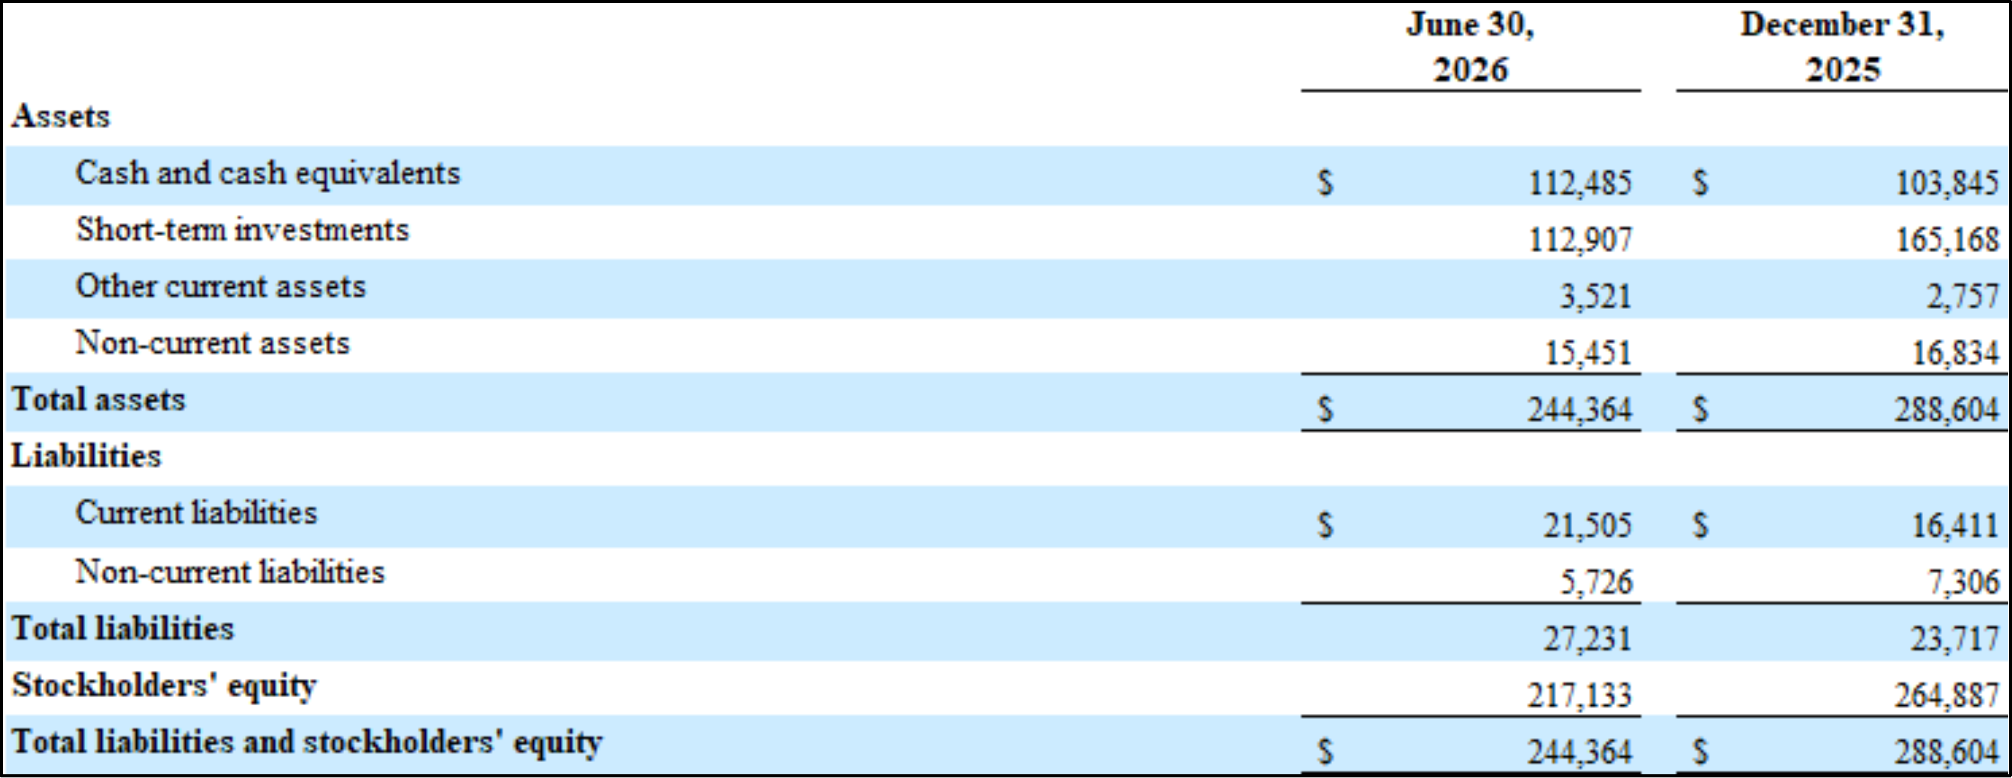

Neurogene Inc.
Unaudited Condensed Consolidated Statements of Operations
(In thousands of U.S. dollars, except per share information)

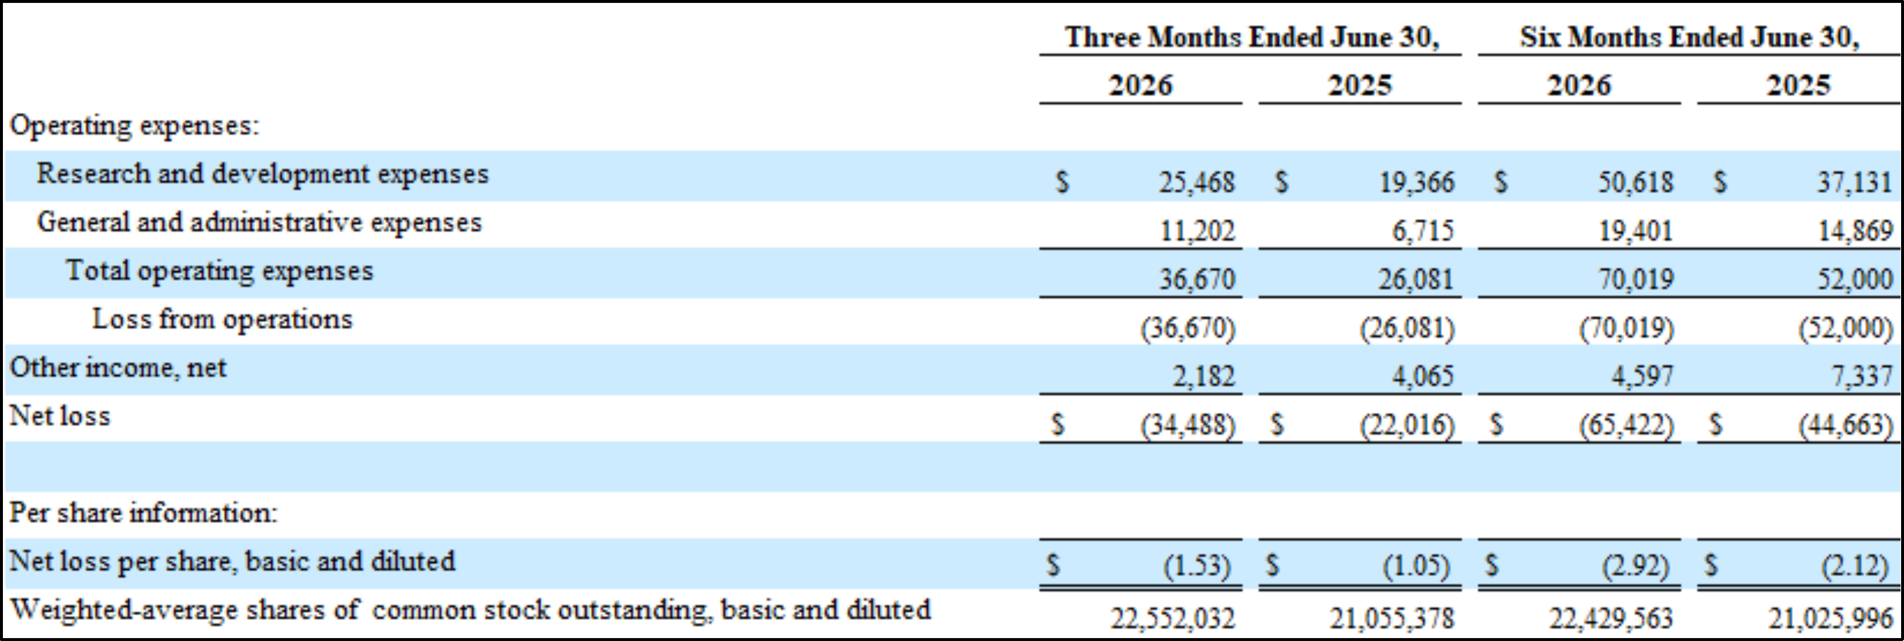

Media Contact:
Mike Devine
Executive Director, Corporate Communications
michael.devine@neurogene.com

Investor Contact:
Lina Li
Executive Director, Investor Relations
lina.li@neurogene.com

###


EVERY BREAKTHROUGH BEGINS WITH BELIEF August 2026 Corporate Presentation

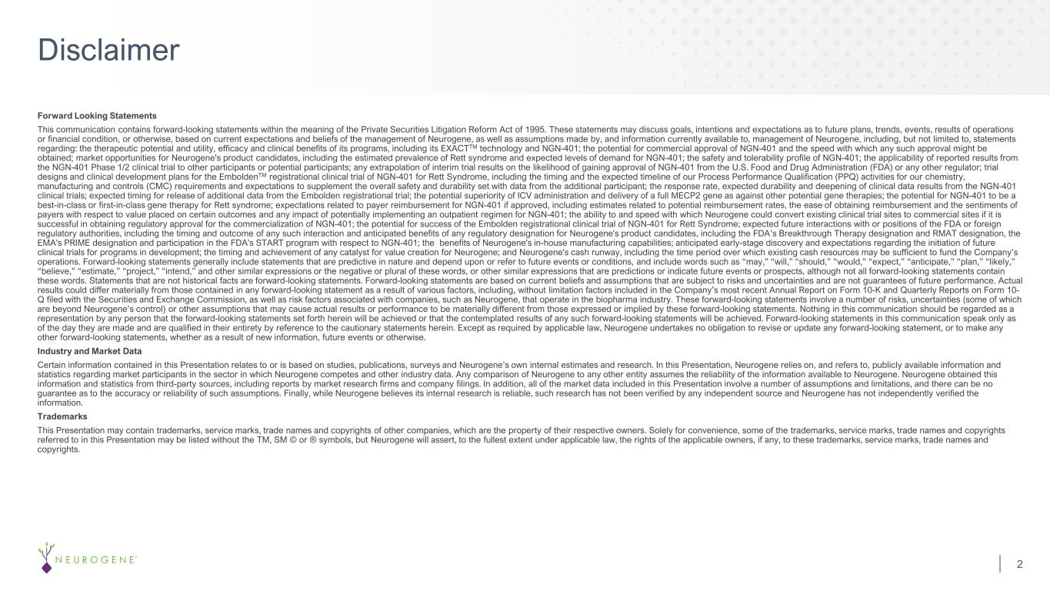
Forward Looking Statements This communication contains forward-looking statements within the meaning of the Private Securities Litigation Reform Act of 1995. These statements may discuss goals, intentions and expectations as to future plans, trends, events, results of operations or financial condition, or otherwise, based on current expectations and beliefs of the management of Neurogene, as well as assumptions made by, and information currently available to, management of Neurogene, including, but not limited to, statements regarding: the therapeutic potential and utility, efficacy and clinical benefits of its programs, including its EXACTTM technology and NGN-401; the potential for commercial approval of NGN-401 and the speed with which any such approval might be obtained; market opportunities for Neurogene's product candidates, including the estimated prevalence of Rett syndrome and expected levels of demand for NGN-401; the safety and tolerability profile of NGN-401; the applicability of reported results from the NGN-401 Phase 1/2 clinical trial to other participants or potential participants; any extrapolation of interim trial results on the likelihood of gaining approval of NGN-401 from the U.S. Food and Drug Administration (FDA) or any other regulator; trial designs and clinical development plans for the EmboldenTM registrational clinical trial of NGN-401 for Rett Syndrome, including the timing and the expected timeline of our Process Performance Qualification (PPQ) activities for our chemistry, manufacturing and controls (CMC) requirements and expectations to supplement the overall safety and durability set with data from the additional participant; the response rate, expected durability and deepening of clinical data results from the NGN-401 clinical trials; expected timing for release of additional data from the Embolden registrational trial; the potential superiority of ICV administration and delivery of a full MECP2 gene as against other potential gene therapies; the potential for NGN-401 to be a best-in-class or first-in-class gene therapy for Rett syndrome; expectations related to payer reimbursement for NGN-401 if approved, including estimates related to potential reimbursement rates, the ease of obtaining reimbursement and the sentiments of payers with respect to value placed on certain outcomes and any impact of potentially implementing an outpatient regimen for NGN-401; the ability to and speed with which Neurogene could convert existing clinical trial sites to commercial sites if it is successful in obtaining regulatory approval for the commercialization of NGN-401; the potential for success of the Embolden registrational clinical trial of NGN-401 for Rett Syndrome; expected future interactions with or positions of the FDA or foreign regulatory authorities, including the timing and outcome of any such interaction and anticipated benefits of any regulatory designation for Neurogene's product candidates, including the FDA’s Breakthrough Therapy designation and RMAT designation, the EMA's PRIME designation and participation in the FDA's START program with respect to NGN-401; the benefits of Neurogene's in-house manufacturing capabilities; anticipated early-stage discovery and expectations regarding the initiation of future clinical trials for programs in development; the timing and achievement of any catalyst for value creation for Neurogene; and Neurogene's cash runway, including the time period over which existing cash resources may be sufficient to fund the Company’s operations. Forward-looking statements generally include statements that are predictive in nature and depend upon or refer to future events or conditions, and include words such as “may,” “will,” “should,” “would,” “expect,” “anticipate,” “plan,” “likely,” “believe,” “estimate,” “project,” “intend,” and other similar expressions or the negative or plural of these words, or other similar expressions that are predictions or indicate future events or prospects, although not all forward-looking statements contain these words. Statements that are not historical facts are forward-looking statements. Forward-looking statements are based on current beliefs and assumptions that are subject to risks and uncertainties and are not guarantees of future performance. Actual results could differ materially from those contained in any forward-looking statement as a result of various factors, including, without limitation factors included in the Company’s most recent Annual Report on Form 10-K and Quarterly Reports on Form 10- Q filed with the Securities and Exchange Commission, as well as risk factors associated with companies, such as Neurogene, that operate in the biopharma industry. These forward-looking statements involve a number of risks, uncertainties (some of which are beyond Neurogene’s control) or other assumptions that may cause actual results or performance to be materially different from those expressed or implied by these forward-looking statements. Nothing in this communication should be regarded as a representation by any person that the forward-looking statements set forth herein will be achieved or that the contemplated results of any such forward-looking statements will be achieved. Forward-looking statements in this communication speak only as of the day they are made and are qualified in their entirety by reference to the cautionary statements herein. Except as required by applicable law, Neurogene undertakes no obligation to revise or update any forward-looking statement, or to make any other forward-looking statements, whether as a result of new information, future events or otherwise. Industry and Market Data Certain information contained in this Presentation relates to or is based on studies, publications, surveys and Neurogene’s own internal estimates and research. In this Presentation, Neurogene relies on, and refers to, publicly available information and statistics regarding market participants in the sector in which Neurogene competes and other industry data. Any comparison of Neurogene to any other entity assumes the reliability of the information available to Neurogene. Neurogene obtained this information and statistics from third-party sources, including reports by market research firms and company filings. In addition, all of the market data included in this Presentation involve a number of assumptions and limitations, and there can be no guarantee as to the accuracy or reliability of such assumptions. Finally, while Neurogene believes its internal research is reliable, such research has not been verified by any independent source and Neurogene has not independently verified the information. Trademarks This Presentation may contain trademarks, service marks, trade names and copyrights of other companies, which are the property of their respective owners. Solely for convenience, some of the trademarks, service marks, trade names and copyrights referred to in this Presentation may be listed without the TM, SM © or ® symbols, but Neurogene will assert, to the fullest extent under applicable law, the rights of the applicable owners, if any, to these trademarks, service marks, trade names and copyrights. Disclaimer 2

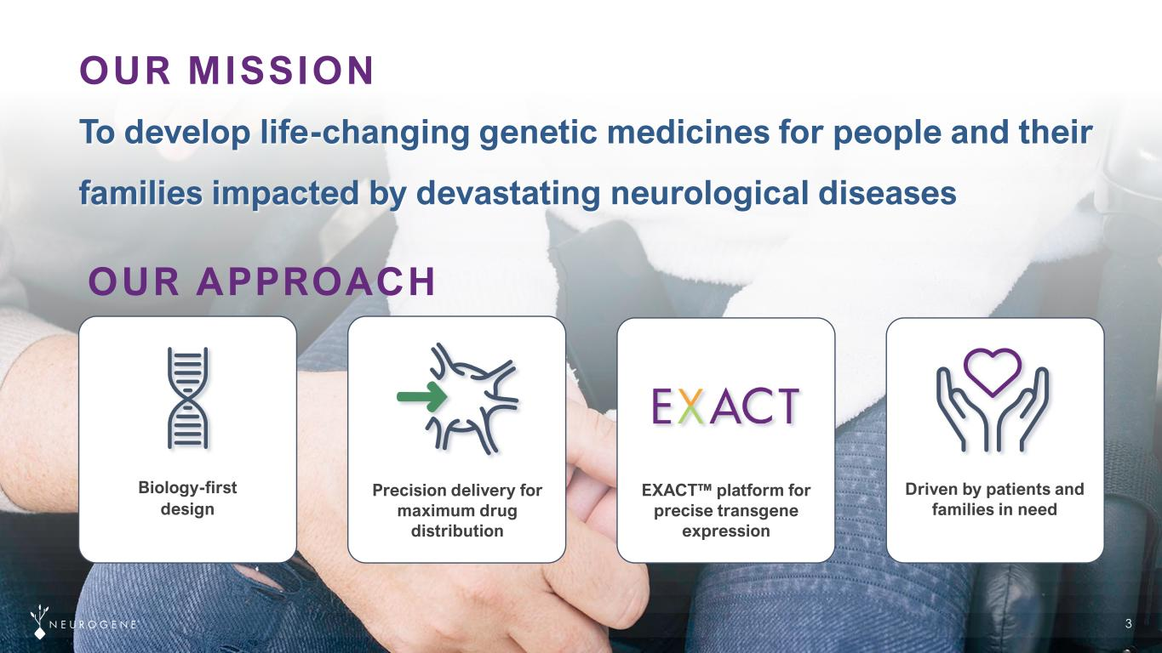
3 To develop life-changing genetic medicines for people and their families impacted by devastating neurological diseases OUR MISSION Biology-first design Precision delivery for maximum drug distribution EXACT platform for precise transgene expression Driven by patients and families in need OUR APPROACH

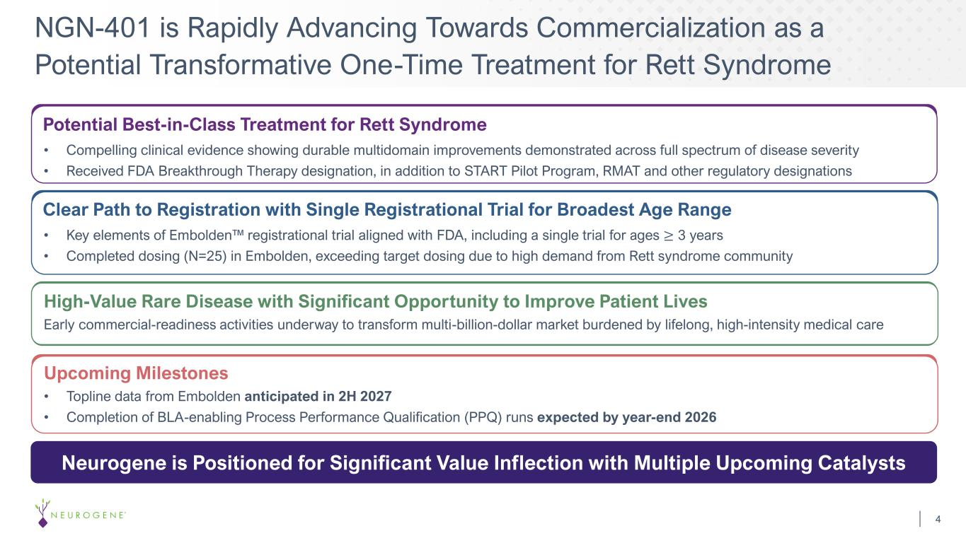
NGN-401 is Rapidly Advancing Towards Commercialization as a Potential Transformative One-Time Treatment for Rett Syndrome 4 Clear Path to Registration with Single Registrational Trial for Broadest Age Range • Key elements of Embolden registrational trial aligned with FDA, including a single trial for ages ≥ 3 years • Completed dosing (N=25) in Embolden, exceeding target dosing due to high demand from Rett syndrome community High-Value Rare Disease with Significant Opportunity to Improve Patient Lives Early commercial-readiness activities underway to transform multi-billion-dollar market burdened by lifelong, high-intensity medical care Upcoming Milestones • Topline data from Embolden anticipated in 2H 2027 • Completion of BLA-enabling Process Performance Qualification (PPQ) runs expected by year-end 2026 Neurogene is Positioned for Significant Value Inflection with Multiple Upcoming Catalysts Potential Best-in-Class Treatment for Rett Syndrome • Compelling clinical evidence showing durable multidomain improvements demonstrated across full spectrum of disease severity • Received FDA Breakthrough Therapy designation, in addition to START Pilot Program, RMAT and other regulatory designations

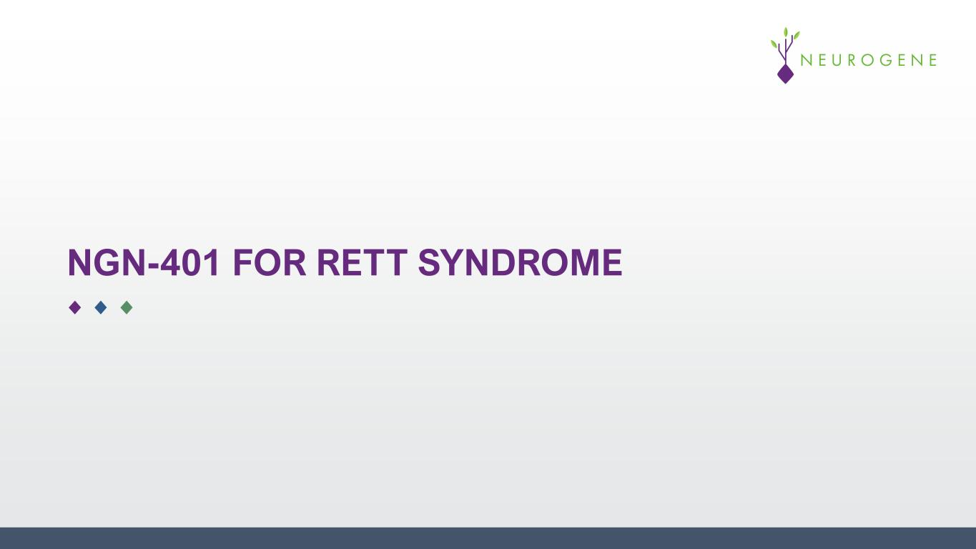
NGN-401 FOR RETT SYNDROME

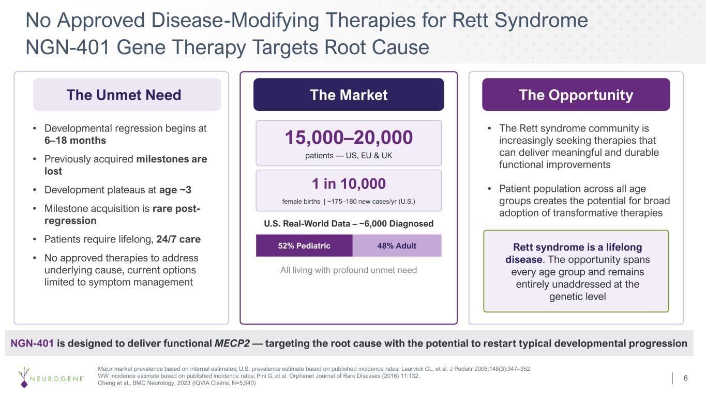
6 No Approved Disease-Modifying Therapies for Rett Syndrome NGN-401 Gene Therapy Targets Root Cause The Unmet Need • Developmental regression begins at 6–18 months • Previously acquired milestones are lost • Development plateaus at age ~3 • Milestone acquisition is rare post- regression • Patients require lifelong, 24/7 care • No approved therapies to address underlying cause, current options limited to symptom management The Market 15,000–20,000 patients — US, EU & UK 1 in 10,000 female births | ~175–180 new cases/yr (U.S.) U.S. Real-World Data – ~6,000 Diagnosed 52% Pediatric 48% Adult All living with profound unmet need The Opportunity • The Rett syndrome community is increasingly seeking therapies that can deliver meaningful and durable functional improvements • Patient population across all age groups creates the potential for broad adoption of transformative therapies Rett syndrome is a lifelong disease. The opportunity spans every age group and remains entirely unaddressed at the genetic level NGN-401 is designed to deliver functional MECP2 — targeting the root cause with the potential to restart typical developmental progression Major market prevalence based on internal estimates; U.S. prevalence estimate based on published incidence rates; Laurvick CL, et al. J Pediatr 2006;148(3):347–352. WW incidence estimate based on published incidence rates; Pini G, et al. Orphanet Journal of Rare Diseases (2016) 11:132. Cheng et al., BMC Neurology, 2023 (IQVIA Claims, N=5,940)

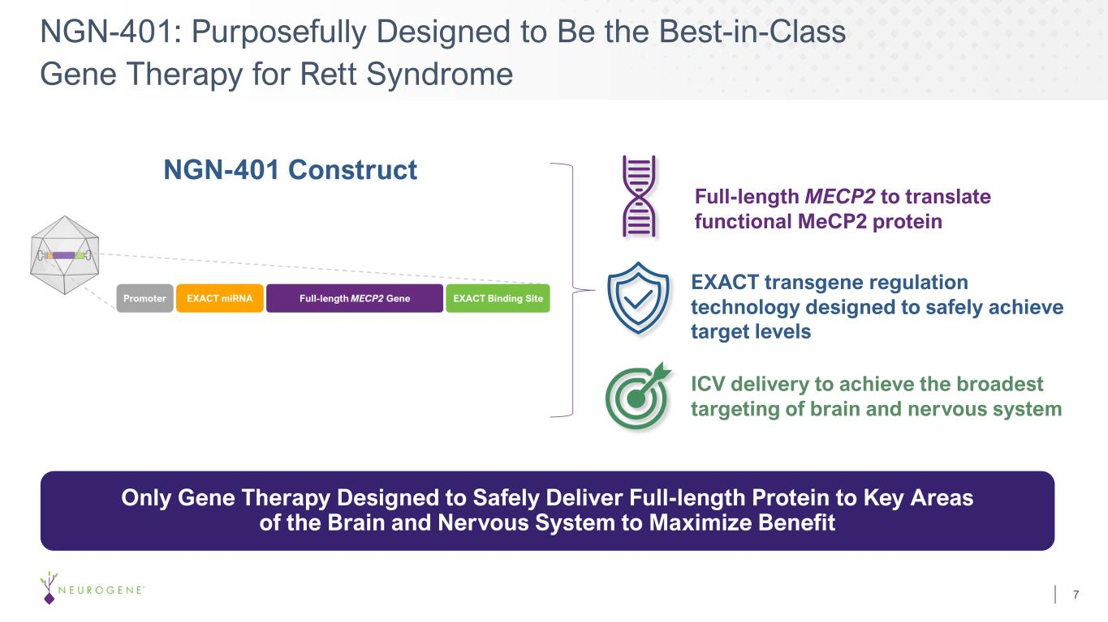
NGN-401: Purposefully Designed to Be the Best-in-Class Gene Therapy for Rett Syndrome 7 Full-length MECP2 to translate functional MeCP2 protein NGN-401 Construct Only Gene Therapy Designed to Safely Deliver Full-length Protein to Key Areas of the Brain and Nervous System to Maximize Benefit ICV delivery to achieve the broadest targeting of brain and nervous system EXACT transgene regulation technology designed to safely achieve target levels

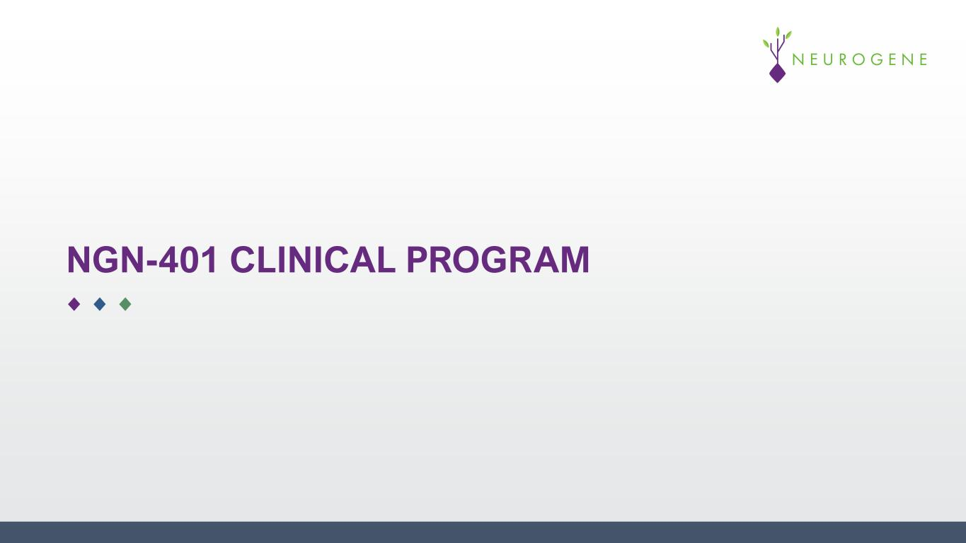
NGN-401 CLINICAL PROGRAM

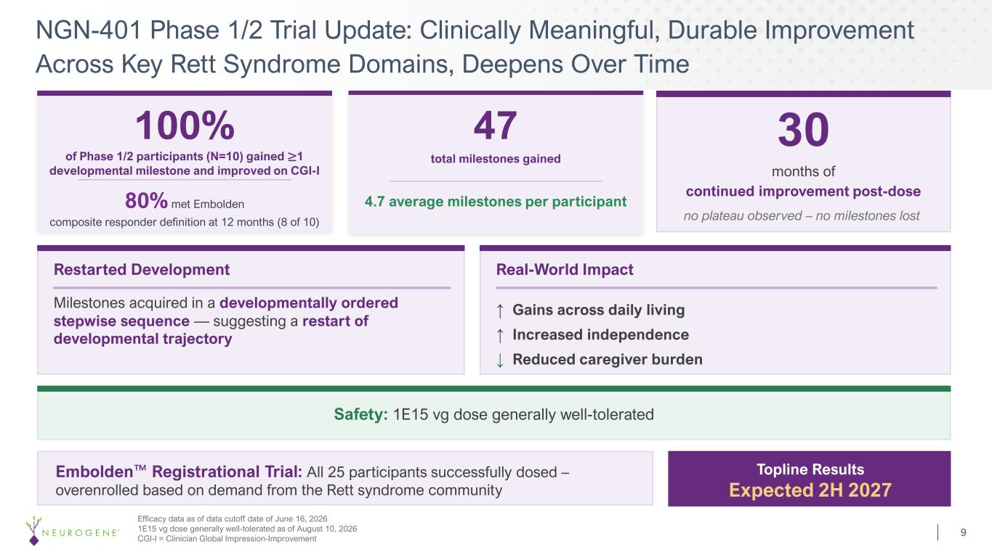
NGN-401 Phase 1/2 Trial Update: Clinically Meaningful, Durable Improvement Across Key Rett Syndrome Domains, Deepens Over Time 9 30 months of continued improvement post-dose no plateau observed – no milestones lost Restarted Development Milestones acquired in a developmentally ordered stepwise sequence — suggesting a restart of developmental trajectory Real-World Impact ↑ Gains across daily living ↑ Increased independence ↓ Reduced caregiver burden Embolden Registrational Trial: All 25 participants successfully dosed – overenrolled based on demand from the Rett syndrome community Topline Results Expected 2H 2027 Efficacy data as of data cutoff date of June 16, 2026 1E15 vg dose generally well-tolerated as of August 10, 2026 CGI-I = Clinician Global Impression-Improvement 100% of Phase 1/2 participants (N=10) gained ≥1 developmental milestone and improved on CGI-I 80% met Embolden composite responder definition at 12 months (8 of 10) 47 total milestones gained 4.7 average milestones per participant Safety: 1E15 vg dose generally well-tolerated

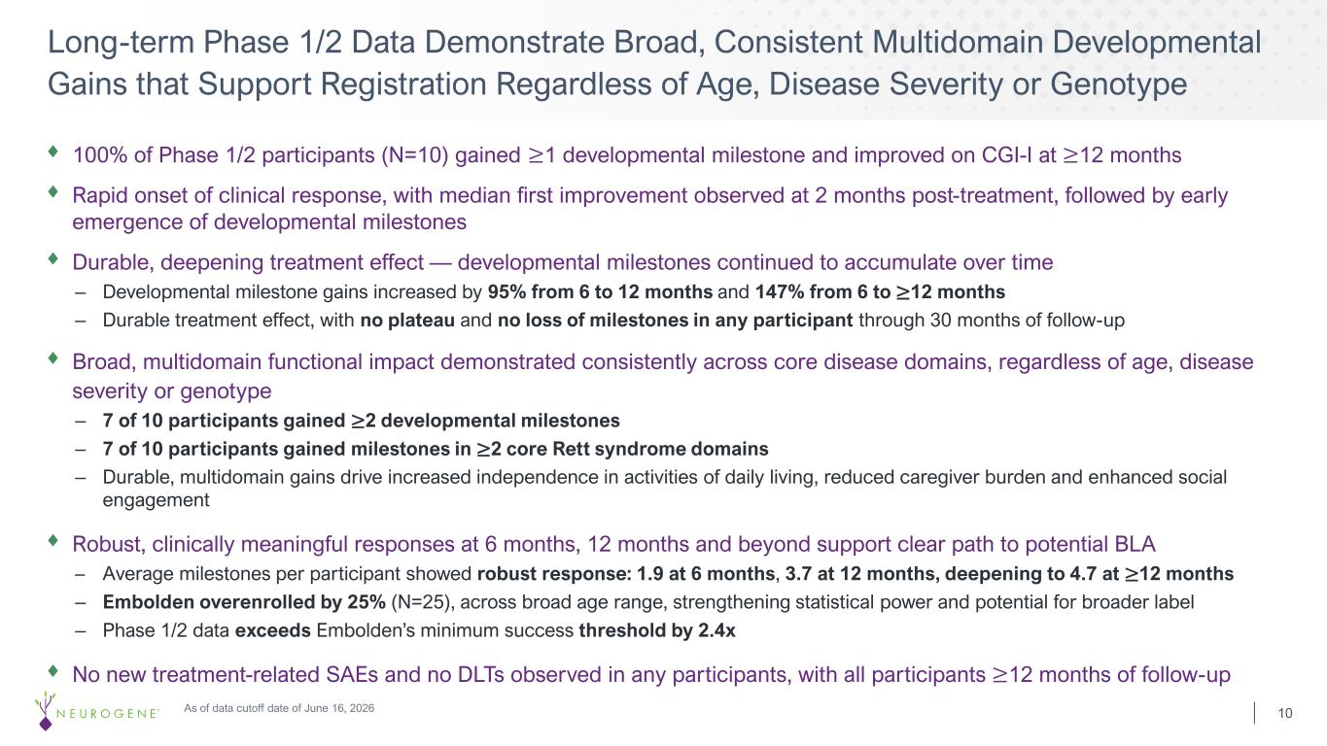
100% of Phase 1/2 participants (N=10) gained ≥1 developmental milestone and improved on CGI-I at ≥12 months Rapid onset of clinical response, with median first improvement observed at 2 months post-treatment, followed by early emergence of developmental milestones Durable, deepening treatment effect — developmental milestones continued to accumulate over time – Developmental milestone gains increased by 95% from 6 to 12 months and 147% from 6 to ≥12 months – Durable treatment effect, with no plateau and no loss of milestones in any participant through 30 months of follow-up Broad, multidomain functional impact demonstrated consistently across core disease domains, regardless of age, disease severity or genotype – 7 of 10 participants gained ≥2 developmental milestones – 7 of 10 participants gained milestones in ≥2 core Rett syndrome domains – Durable, multidomain gains drive increased independence in activities of daily living, reduced caregiver burden and enhanced social engagement Robust, clinically meaningful responses at 6 months, 12 months and beyond support clear path to potential BLA – Average milestones per participant showed robust response: 1.9 at 6 months, 3.7 at 12 months, deepening to 4.7 at ≥12 months – Embolden overenrolled by 25% (N=25), across broad age range, strengthening statistical power and potential for broader label – Phase 1/2 data exceeds Embolden’s minimum success threshold by 2.4x No new treatment-related SAEs and no DLTs observed in any participants, with all participants ≥12 months of follow-up Long-term Phase 1/2 Data Demonstrate Broad, Consistent Multidomain Developmental Gains that Support Registration Regardless of Age, Disease Severity or Genotype 10As of data cutoff date of June 16, 2026

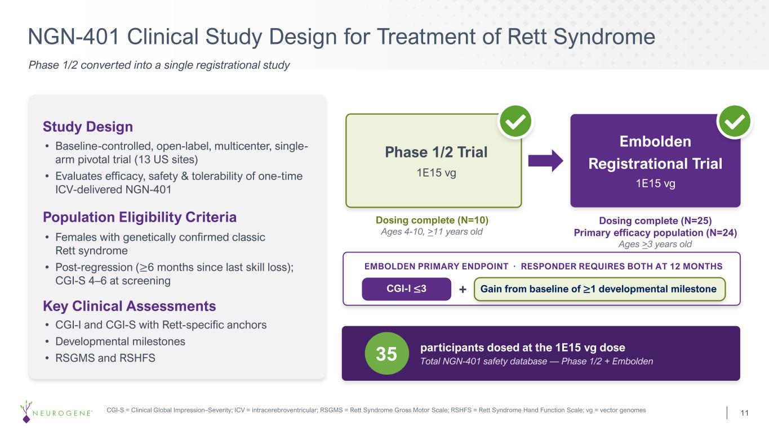
NGN-401 Clinical Study Design for Treatment of Rett Syndrome 11 Phase 1/2 converted into a single registrational study Study Design • Baseline-controlled, open-label, multicenter, single- arm pivotal trial (13 US sites) • Evaluates efficacy, safety & tolerability of one-time ICV-delivered NGN-401 Population Eligibility Criteria • Females with genetically confirmed classic Rett syndrome • Post-regression (≥6 months since last skill loss); CGI-S 4–6 at screening Key Clinical Assessments • CGI-I and CGI-S with Rett-specific anchors • Developmental milestones • RSGMS and RSHFS Phase 1/2 Trial 1E15 vg Dosing complete (N=10) Ages 4-10, >11 years old Embolden Registrational Trial 1E15 vg Dosing complete (N=25) Primary efficacy population (N=24) Ages >3 years old 35 CGI-I ≤3 + EMBOLDEN PRIMARY ENDPOINT · RESPONDER REQUIRES BOTH AT 12 MONTHS Gain from baseline of ≥1 developmental milestone participants dosed at the 1E15 vg dose Total NGN-401 safety database — Phase 1/2 + Embolden CGI-S = Clinical Global Impression–Severity; ICV = intracerebroventricular; RSGMS = Rett Syndrome Gross Motor Scale; RSHFS = Rett Syndrome Hand Function Scale; vg = vector genomes

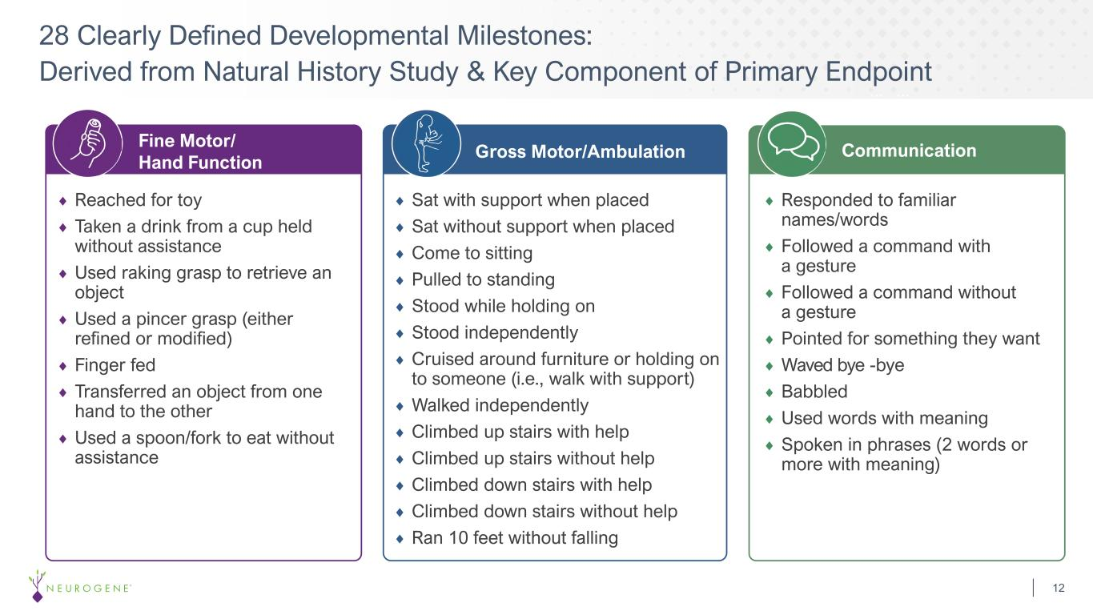
28 Clearly Defined Developmental Milestones: Derived from Natural History Study & Key Component of Primary Endpoint 12 Fine Motor/ Hand Function Gross Motor/Ambulation Communication Reached for toy Taken a drink from a cup held without assistance Used raking grasp to retrieve an object Used a pincer grasp (either refined or modified) Finger fed Transferred an object from one hand to the other Used a spoon/fork to eat without assistance Sat with support when placed Sat without support when placed Come to sitting Pulled to standing Stood while holding on Stood independently Cruised around furniture or holding on to someone (i.e., walk with support) Walked independently Climbed up stairs with help Climbed up stairs without help Climbed down stairs with help Climbed down stairs without help Ran 10 feet without falling Responded to familiar names/words Followed a command with a gesture Followed a command without a gesture Pointed for something they want Waved bye -bye Babbled Used words with meaning Spoken in phrases (2 words or more with meaning)

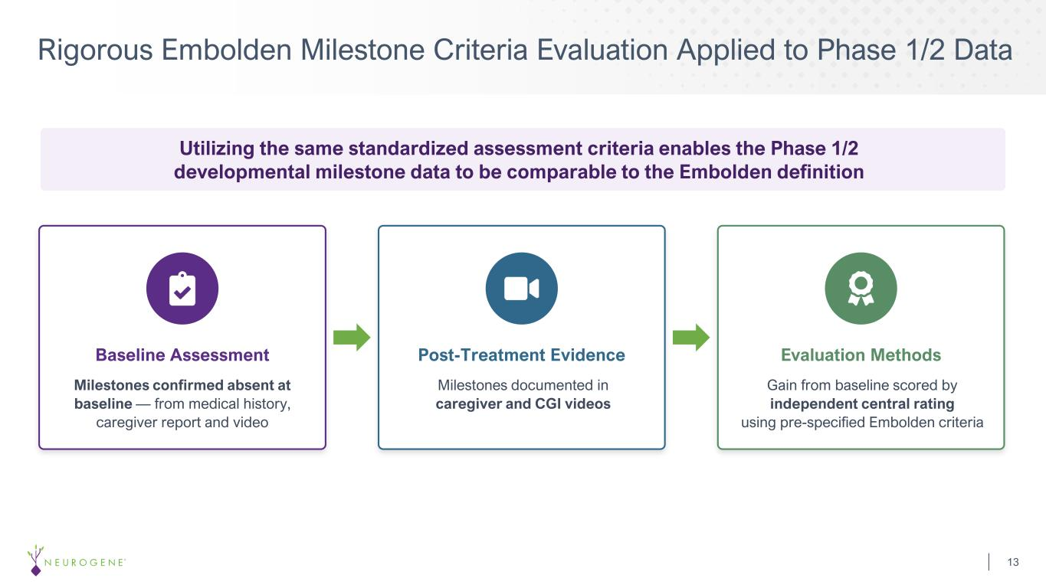
Rigorous Embolden Milestone Criteria Evaluation Applied to Phase 1/2 Data 13 Baseline Assessment Post-Treatment Evidence Milestones documented in caregiver and CGI videos Evaluation Methods Gain from baseline scored by independent central rating using pre-specified Embolden criteria Utilizing the same standardized assessment criteria enables the Phase 1/2 developmental milestone data to be comparable to the Embolden definition Milestones confirmed absent at baseline — from medical history, caregiver report and video

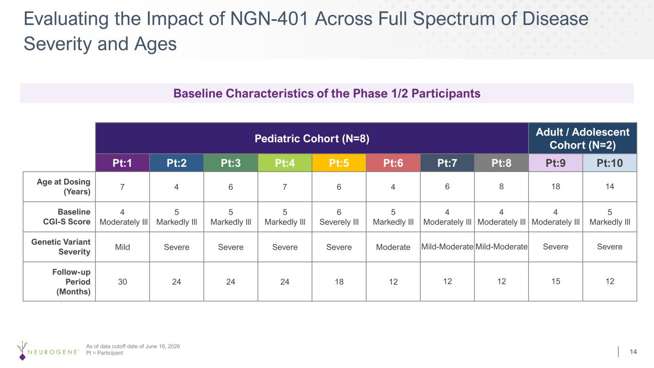
Evaluating the Impact of NGN-401 Across Full Spectrum of Disease Severity and Ages 14 As of data cutoff date of June 16, 2026 Pt = Participant Pediatric Cohort (N=8) Adult / Adolescent Cohort (N=2) Pt:1 Pt:2 Pt:3 Pt:4 Pt:5 Pt:6 Pt:7 Pt:8 Pt:9 Pt:10 Age at Dosing (Years) 7 4 6 7 6 4 6 8 18 14 Baseline CGI-S Score 4 Moderately Ill 5 Markedly Ill 5 Markedly Ill 5 Markedly Ill 6 Severely Ill 5 Markedly Ill 4 Moderately Ill 4 Moderately Ill 4 Moderately Ill 5 Markedly Ill Genetic Variant Severity Mild Severe Severe Severe Severe Moderate Mild-Moderate Mild-Moderate Severe Severe Follow-up Period (Months) 30 24 24 24 18 12 12 12 15 12 Baseline Characteristics of the Phase 1/2 Participants

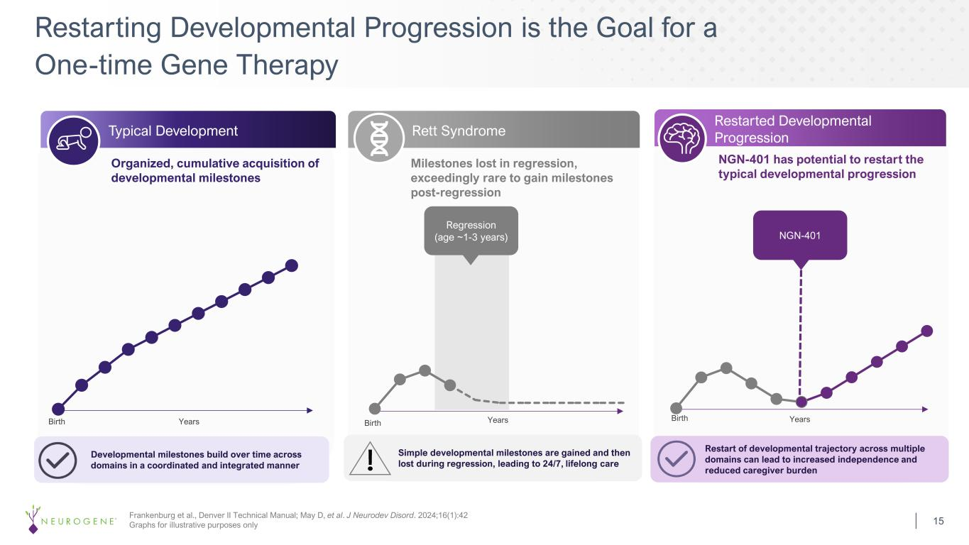
Restarting Developmental Progression is the Goal for a One-time Gene Therapy 15 Frankenburg et al., Denver II Technical Manual; May D, et al. J Neurodev Disord. 2024;16(1):42 Graphs for illustrative purposes only Typical Development Rett Syndrome Restarted Developmental Progression Birth Birth Birth Regression (age ~1-3 years) NGN-401 Organized, cumulative acquisition of developmental milestones Milestones lost in regression, exceedingly rare to gain milestones post-regression NGN-401 has potential to restart the typical developmental progression Developmental milestones build over time across domains in a coordinated and integrated manner Simple developmental milestones are gained and then lost during regression, leading to 24/7, lifelong care Restart of developmental trajectory across multiple domains can lead to increased independence and reduced caregiver burden Years Years Years

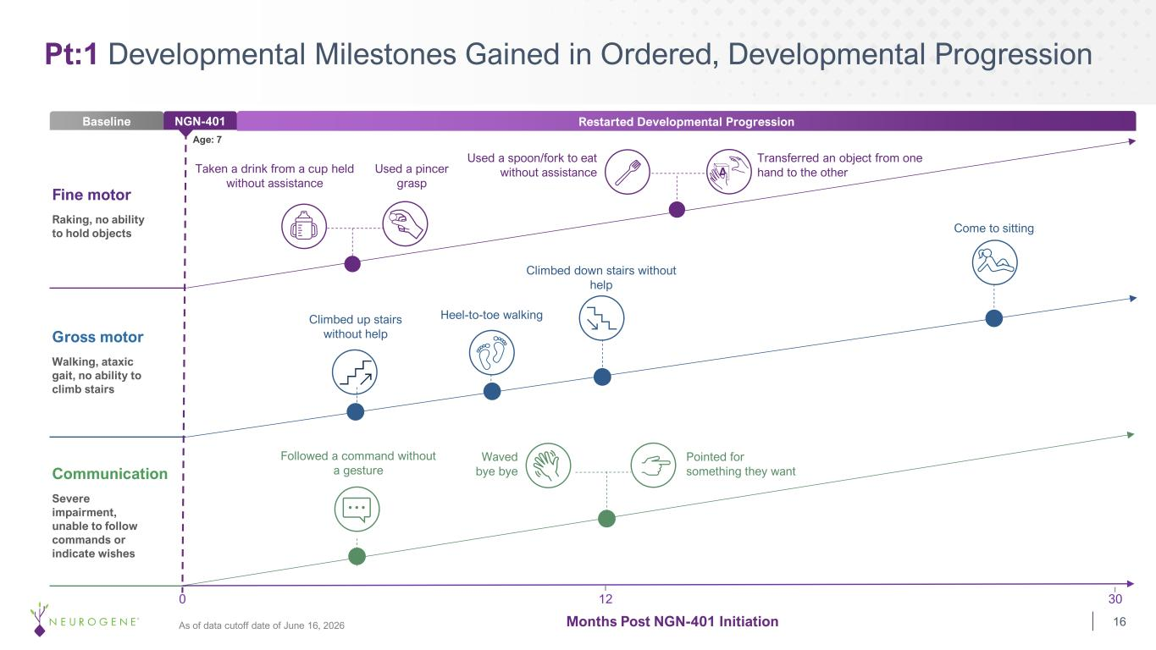
Pt:1 Developmental Milestones Gained in Ordered, Developmental Progression Baseline NGN-401 Restarted Developmental Progression 12 300 Taken a drink from a cup held without assistance Used a pincer grasp Used a spoon/fork to eat without assistance Transferred an object from one hand to the other Climbed up stairs without help Climbed down stairs without help Heel-to-toe walking Come to sitting Followed a command without a gesture Pointed for something they want Waved bye bye Fine motor Raking, no ability to hold objects Gross motor Walking, ataxic gait, no ability to climb stairs Communication Severe impairment, unable to follow commands or indicate wishes Age: 7 Months Post NGN-401 Initiation 16As of data cutoff date of June 16, 2026

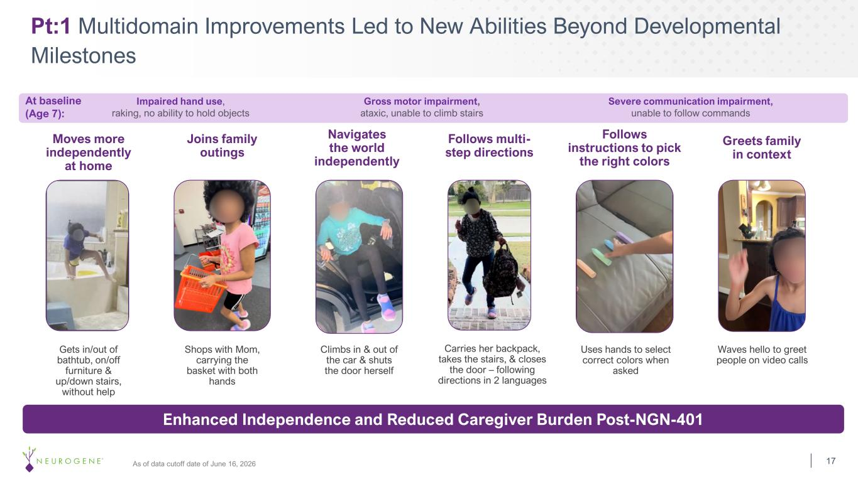
Pt:1 Multidomain Improvements Led to New Abilities Beyond Developmental Milestones Moves more independently at home Gets in/out of bathtub, on/off furniture & up/down stairs, without help Shops with Mom, carrying the basket with both hands Joins family outings Navigates the world independently Climbs in & out of the car & shuts the door herself Follows multi- step directions Carries her backpack, takes the stairs, & closes the door – following directions in 2 languages Follows instructions to pick the right colors Uses hands to select correct colors when asked Greets family in context Waves hello to greet people on video calls Enhanced Independence and Reduced Caregiver Burden Post-NGN-401 17 Impaired hand use, raking, no ability to hold objects At baseline (Age 7): Gross motor impairment, ataxic, unable to climb stairs Severe communication impairment, unable to follow commands As of data cutoff date of June 16, 2026

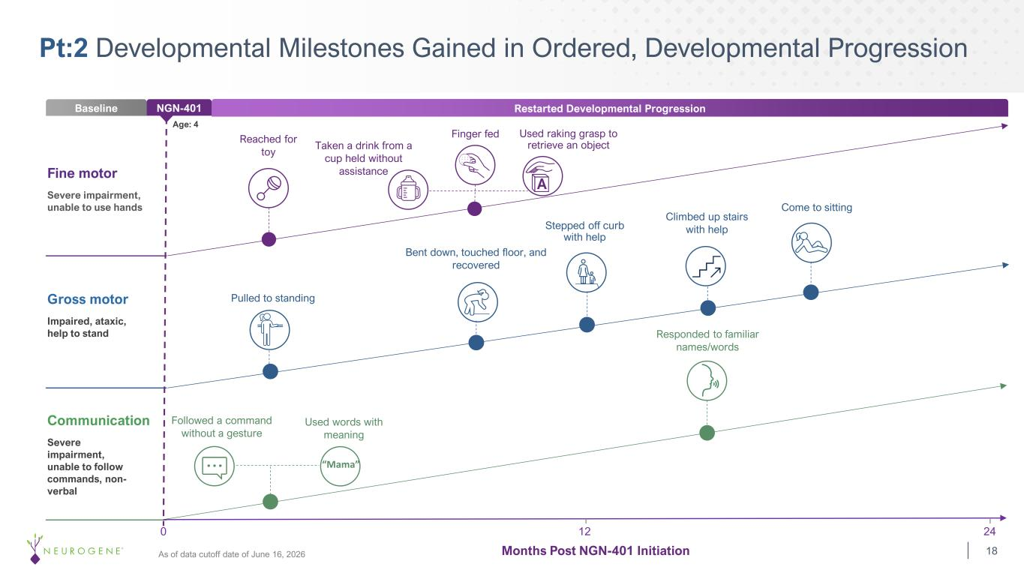
Pt:2 Developmental Milestones Gained in Ordered, Developmental Progression Months Post NGN-401 Initiation 12 240 Baseline NGN-401 Restarted Developmental Progression Fine motor Severe impairment, unable to use hands Gross motor Impaired, ataxic, help to stand Communication Severe impairment, unable to follow commands, non- verbal Age: 4 Reached for toy Taken a drink from a cup held without assistance Finger fed Used raking grasp to retrieve an object Pulled to standing Stepped off curb with help Bent down, touched floor, and recovered Come to sitting Followed a command without a gesture Responded to familiar names/words Climbed up stairs with help Used words with meaning “Mama” 18As of data cutoff date of June 16, 2026

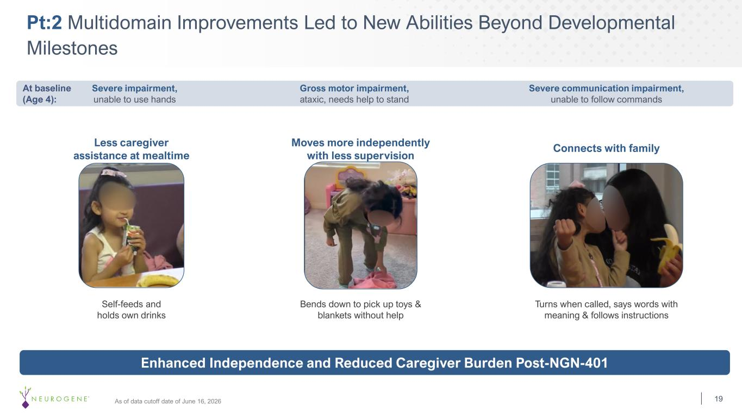
Pt:2 Multidomain Improvements Led to New Abilities Beyond Developmental Milestones Self-feeds and holds own drinks Bends down to pick up toys & blankets without help Turns when called, says words with meaning & follows instructions Less caregiver assistance at mealtime Moves more independently with less supervision Connects with family Enhanced Independence and Reduced Caregiver Burden Post-NGN-401 19 Gross motor impairment, ataxic, needs help to stand Severe impairment, unable to use hands At baseline (Age 4): Severe communication impairment, unable to follow commands As of data cutoff date of June 16, 2026

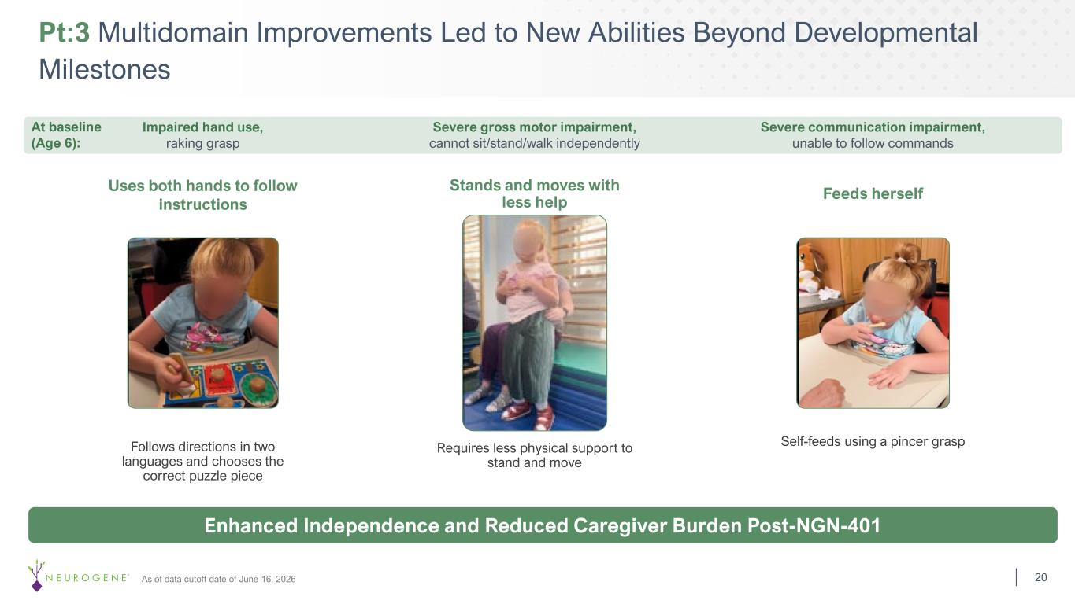
Pt:3 Multidomain Improvements Led to New Abilities Beyond Developmental Milestones 20As of data cutoff date of June 16, 2026 Requires less physical support to stand and move Follows directions in two languages and chooses the correct puzzle piece Self-feeds using a pincer grasp Uses both hands to follow instructions Stands and moves with less help Feeds herself Enhanced Independence and Reduced Caregiver Burden Post-NGN-401 Impaired hand use, raking grasp Severe gross motor impairment, cannot sit/stand/walk independently Severe communication impairment, unable to follow commands At baseline (Age 6):

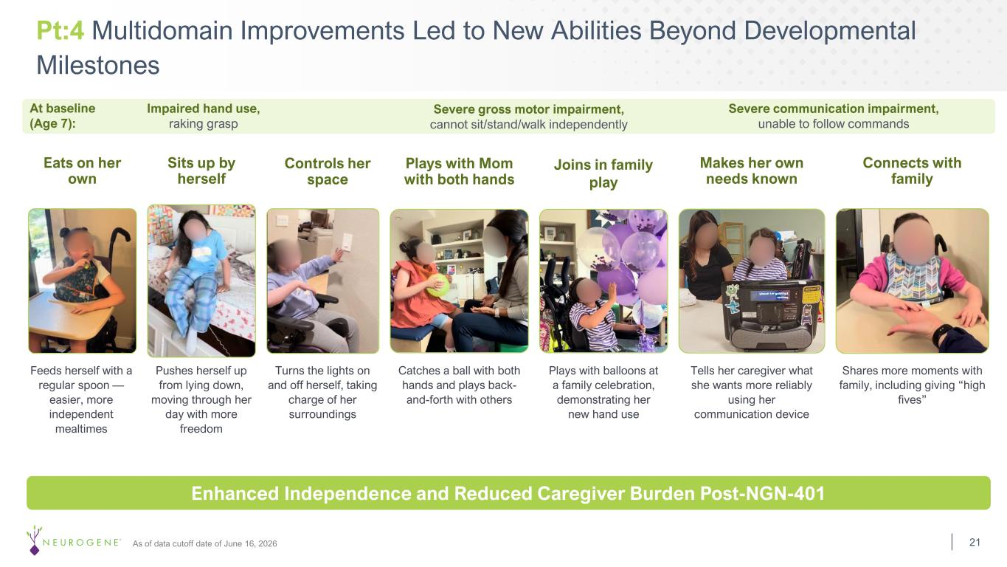
Pt:4 Multidomain Improvements Led to New Abilities Beyond Developmental Milestones As of data cutoff date of June 16, 2026 Turns the lights on and off herself, taking charge of her surroundings Feeds herself with a regular spoon — easier, more independent mealtimes Eats on her own Pushes herself up from lying down, moving through her day with more freedom Sits up by herself Controls her space Catches a ball with both hands and plays back- and-forth with others Plays with Mom with both hands Plays with balloons at a family celebration, demonstrating her new hand use Joins in family play Tells her caregiver what she wants more reliably using her communication device Makes her own needs known Shares more moments with family, including giving “high fives” Connects with family Enhanced Independence and Reduced Caregiver Burden Post-NGN-401 21 Severe gross motor impairment, cannot sit/stand/walk independently Impaired hand use, raking grasp Severe communication impairment, unable to follow commands At baseline (Age 7):

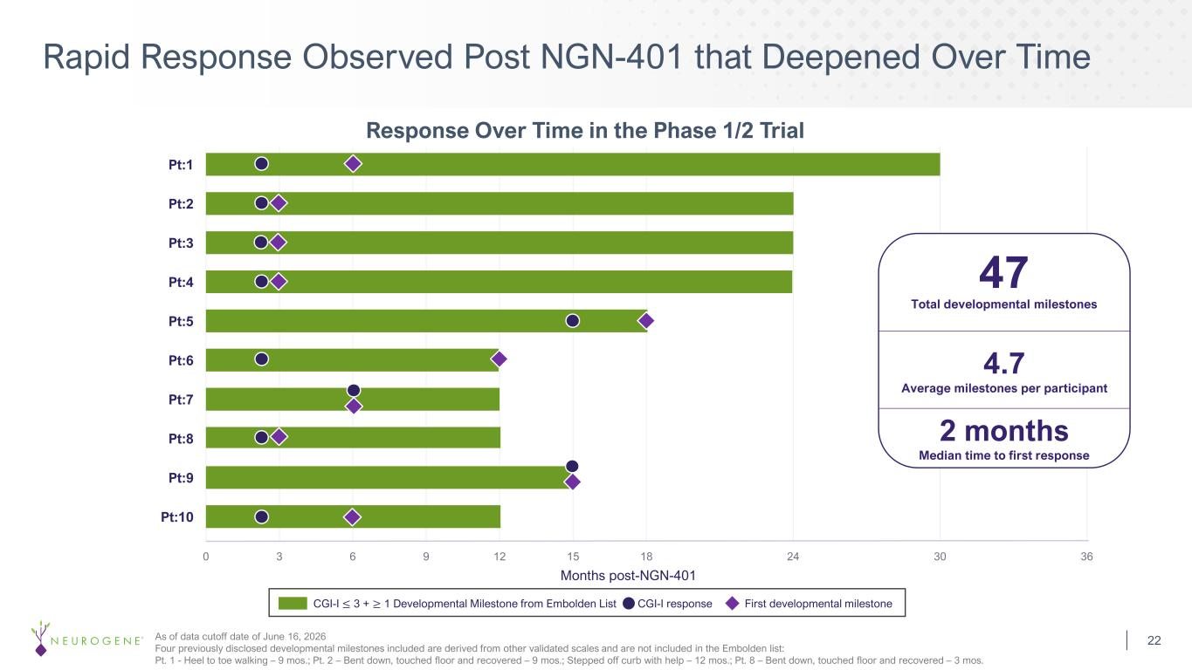
Rapid Response Observed Post NGN-401 that Deepened Over Time 22 0 3 6 9 12 15 18 24 30 36 Months post-NGN-401 Pt:1 Pt:2 Pt:3 Pt:4 Pt:5 Pt:6 Pt:7 Pt:8 Pt:9 Pt:10 Response Over Time in the Phase 1/2 Trial Total developmental milestones 47 4.7 Average milestones per participant CGI-I ≤ 3 + ≥ 1 Developmental Milestone from Embolden List CGI-I response First developmental milestone 2 months Median time to first response As of data cutoff date of June 16, 2026 Four previously disclosed developmental milestones included are derived from other validated scales and are not included in the Embolden list: Pt. 1 - Heel to toe walking – 9 mos.; Pt. 2 – Bent down, touched floor and recovered – 9 mos.; Stepped off curb with help – 12 mos.; Pt. 8 – Bent down, touched floor and recovered – 3 mos.

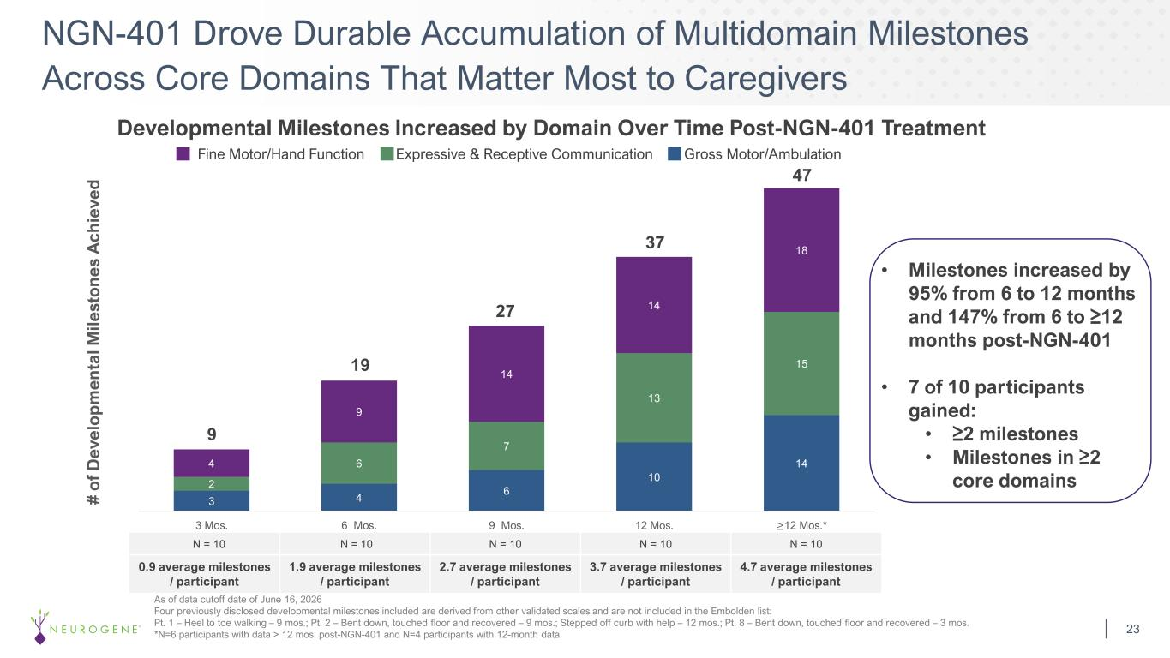
Developmental Milestones Increased by Domain Over Time Post-NGN-401 Treatment NGN-401 Drove Durable Accumulation of Multidomain Milestones Across Core Domains That Matter Most to Caregivers 23 As of data cutoff date of June 16, 2026 Four previously disclosed developmental milestones included are derived from other validated scales and are not included in the Embolden list: Pt. 1 – Heel to toe walking – 9 mos.; Pt. 2 – Bent down, touched floor and recovered – 9 mos.; Stepped off curb with help – 12 mos.; Pt. 8 – Bent down, touched floor and recovered – 3 mos. *N=6 participants with data > 12 mos. post-NGN-401 and N=4 participants with 12-month data 3 4 6 10 14 2 6 7 13 15 4 9 14 14 18 3 Mos. 6 Mos. 9 Mos. 12 Mos. ≥12 Mos.* 19 9 27 37 # o f D ev el o p m en ta l M ile st o n es A ch ie ve d Fine Motor/Hand Function Expressive & Receptive Communication Gross Motor/Ambulation 47 N = 10 N = 10 N = 10 N = 10 N = 10 0.9 average milestones / participant 1.9 average milestones / participant 2.7 average milestones / participant 3.7 average milestones / participant 4.7 average milestones / participant • Milestones increased by 95% from 6 to 12 months and 147% from 6 to ≥12 months post-NGN-401 • 7 of 10 participants gained: • ≥2 milestones • Milestones in ≥2 core domains

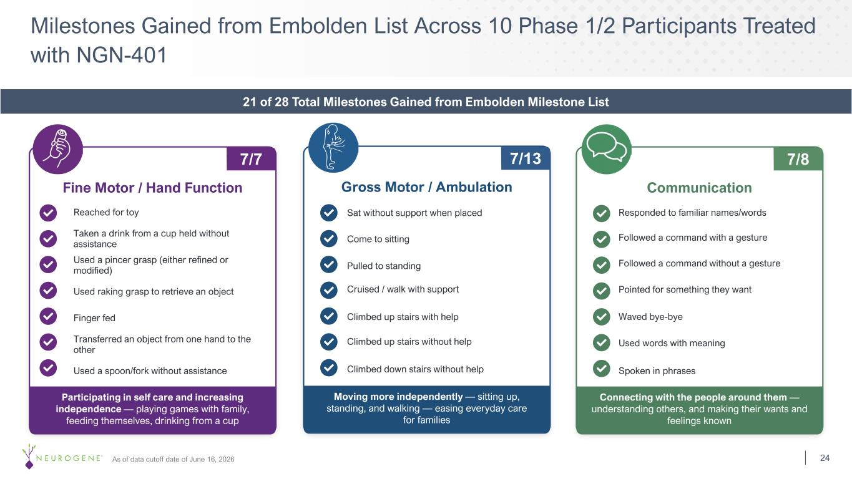
Connecting with the people around them — understanding others, and making their wants and feelings known Communication Spoken in phrases Used words with meaning Pointed for something they want Waved bye-bye Responded to familiar names/words Participating in self care and increasing independence — playing games with family, feeding themselves, drinking from a cup Fine Motor / Hand Function Used a spoon/fork without assistance Taken a drink from a cup held without assistance Finger fed Used a pincer grasp (either refined or modified) Used raking grasp to retrieve an object Reached for toy Transferred an object from one hand to the other Moving more independently — sitting up, standing, and walking — easing everyday care for families Gross Motor / Ambulation Climbed up stairs without help Climbed down stairs without help Climbed up stairs with help Cruised / walk with support Pulled to standing Come to sitting Sat without support when placed Milestones Gained from Embolden List Across 10 Phase 1/2 Participants Treated with NGN-401 24As of data cutoff date of June 16, 2026 7/7 Followed a command with a gesture Followed a command without a gesture 21 of 28 Total Milestones Gained from Embolden Milestone List 7/13 7/8

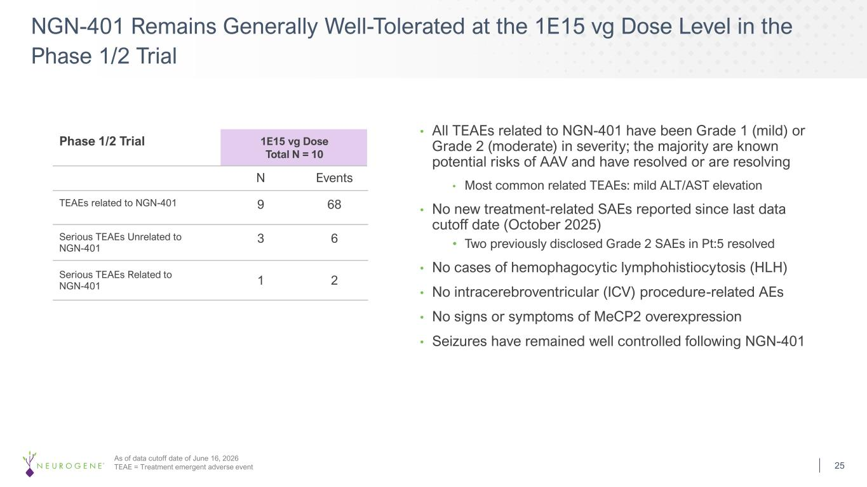
Phase 1/2 Trial 1E15 vg Dose Total N = 10 N Events TEAEs related to NGN-401 9 68 Serious TEAEs Unrelated to NGN-401 3 6 Serious TEAEs Related to NGN-401 1 2 • All TEAEs related to NGN-401 have been Grade 1 (mild) or Grade 2 (moderate) in severity; the majority are known potential risks of AAV and have resolved or are resolving • Most common related TEAEs: mild ALT/AST elevation • No new treatment-related SAEs reported since last data cutoff date (October 2025) • Two previously disclosed Grade 2 SAEs in Pt:5 resolved • No cases of hemophagocytic lymphohistiocytosis (HLH) • No intracerebroventricular (ICV) procedure-related AEs • No signs or symptoms of MeCP2 overexpression • Seizures have remained well controlled following NGN-401 As of data cutoff date of June 16, 2026 TEAE = Treatment emergent adverse event NGN-401 Remains Generally Well-Tolerated at the 1E15 vg Dose Level in the Phase 1/2 Trial 25

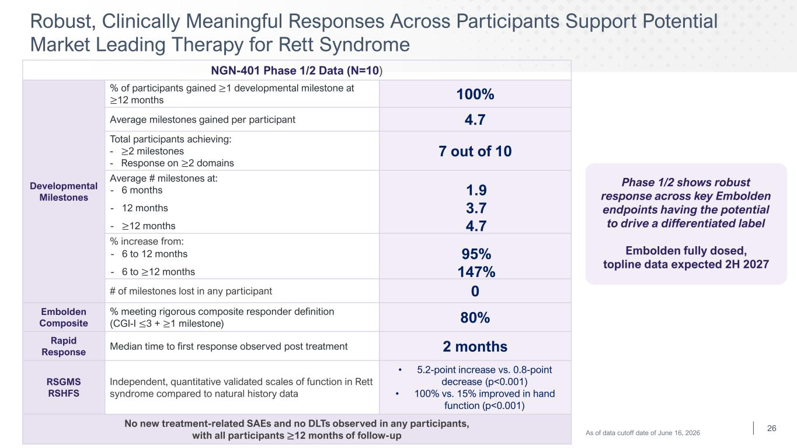
NGN-401 Phase 1/2 Data (N=10) Developmental Milestones % of participants gained ≥1 developmental milestone at ≥12 months 100% Average milestones gained per participant 4.7 Total participants achieving: - ≥2 milestones - Response on ≥2 domains 7 out of 10 Average # milestones at: % increase from: # of milestones lost in any participant 0 Embolden Composite % meeting rigorous composite responder definition (CGI-I ≤3 + ≥1 milestone) 80% Rapid Response Median time to first response observed post treatment 2 months RSGMS RSHFS Independent, quantitative validated scales of function in Rett syndrome compared to natural history data • 5.2-point increase vs. 0.8-point decrease (p<0.001) • 100% vs. 15% improved in hand function (p<0.001) No new treatment-related SAEs and no DLTs observed in any participants, with all participants ≥12 months of follow-up Robust, Clinically Meaningful Responses Across Participants Support Potential Market Leading Therapy for Rett Syndrome Phase 1/2 shows robust response across key Embolden endpoints having the potential to drive a differentiated label Embolden fully dosed, topline data expected 2H 2027 26 - 6 months 1.9 - 12 months 3.7 - ≥12 months 4.7 - 6 to 12 months 95% - 6 to ≥12 months 147% As of data cutoff date of June 16, 2026

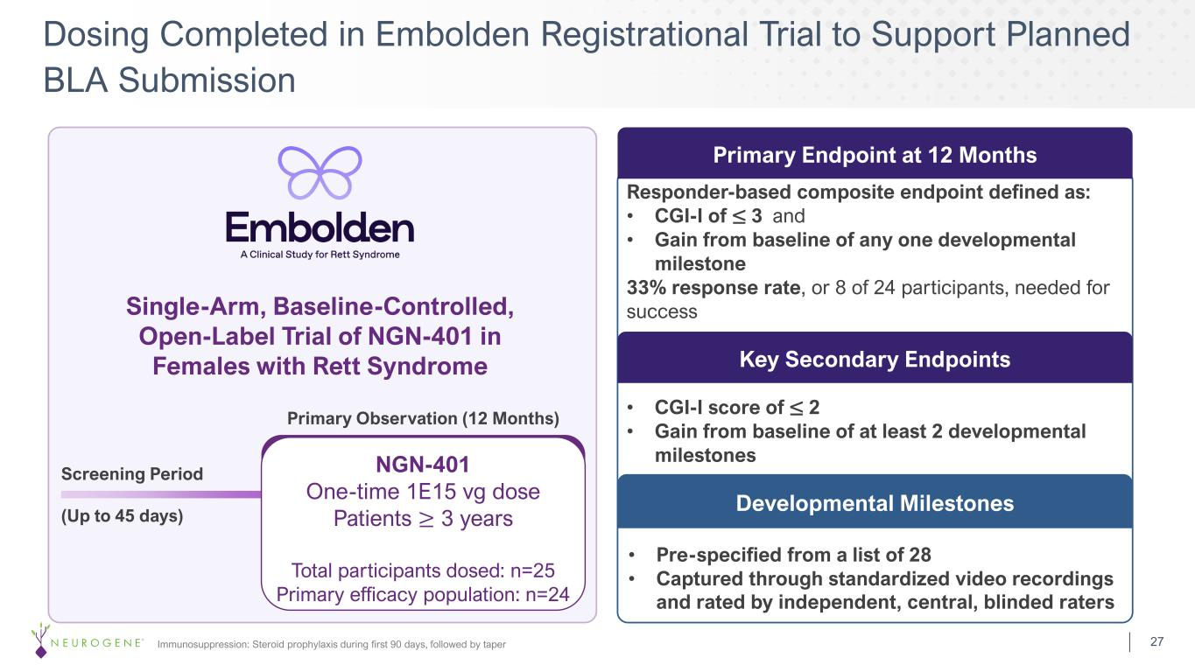
Dosing Completed in Embolden Registrational Trial to Support Planned BLA Submission Immunosuppression: Steroid prophylaxis during first 90 days, followed by taper Developmental Milestones • CGI-I score of ≤ 2 • Gain from baseline of at least 2 developmental milestones Single-Arm, Baseline-Controlled, Open-Label Trial of NGN-401 in Females with Rett Syndrome Responder-based composite endpoint defined as: • CGI-I of ≤ 3 and • Gain from baseline of any one developmental milestone 33% response rate, or 8 of 24 participants, needed for success Primary Endpoint at 12 Months Key Secondary Endpoints • Pre-specified from a list of 28 • Captured through standardized video recordings and rated by independent, central, blinded raters Screening Period (Up to 45 days) NGN-401 One-time 1E15 vg dose Patients ≥ 3 years Total participants dosed: n=25 Primary efficacy population: n=24 Primary Observation (12 Months) 27

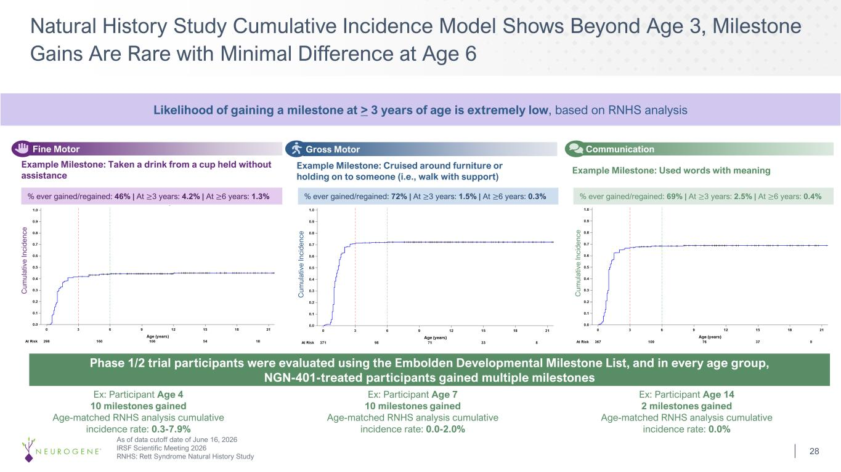
Natural History Study Cumulative Incidence Model Shows Beyond Age 3, Milestone Gains Are Rare with Minimal Difference at Age 6 28 % ever gained/regained: 69% | At ≥3 years: 2.5% | At ≥6 years: 0.4% Communication Example Milestone: Used words with meaning Age (years) % ever gained/regained: 46% | At ≥3 years: 4.2% | At ≥6 years: 1.3% Fine Motor Example Milestone: Taken a drink from a cup held without assistance Age (years) % ever gained/regained: 72% | At ≥3 years: 1.5% | At ≥6 years: 0.3% Gross Motor Example Milestone: Cruised around furniture or holding on to someone (i.e., walk with support) Age (years) Phase 1/2 trial participants were evaluated using the Embolden Developmental Milestone List, and in every age group, NGN-401-treated participants gained multiple milestones Ex: Participant Age 4 10 milestones gained Age-matched RNHS analysis cumulative incidence rate: 0.3-7.9% Ex: Participant Age 7 10 milestones gained Age-matched RNHS analysis cumulative incidence rate: 0.0-2.0% Ex: Participant Age 14 2 milestones gained Age-matched RNHS analysis cumulative incidence rate: 0.0% Likelihood of gaining a milestone at > 3 years of age is extremely low, based on RNHS analysis As of data cutoff date of June 16, 2026 IRSF Scientific Meeting 2026 RNHS: Rett Syndrome Natural History Study C um ul at iv e In ci de nc e C um ul at iv e In ci de nc e C um ul at iv e In ci de nc e

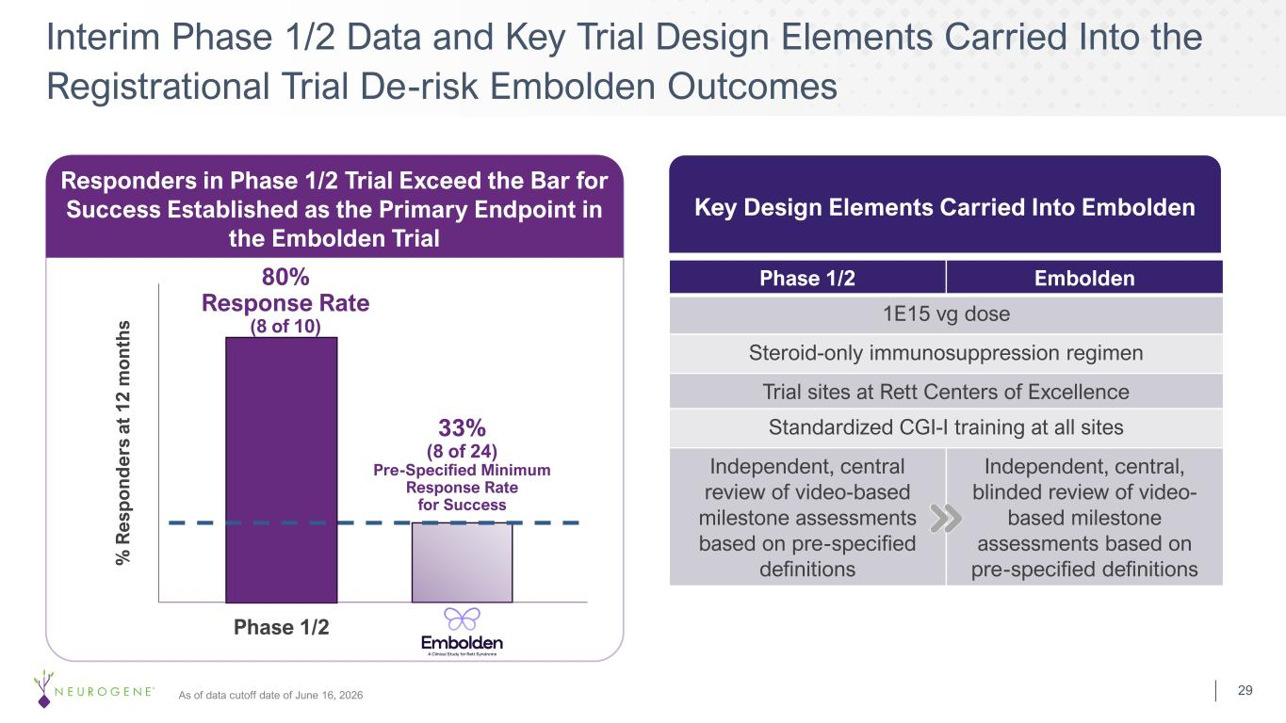
33% (8 of 24) Pre-Specified Minimum Response Rate for Success 80% Response Rate (8 of 10) % R es p o n d er s at 1 2 m o n th s Phase 1/2 Responders in Phase 1/2 Trial Exceed the Bar for Success Established as the Primary Endpoint in the Embolden Trial As of data cutoff date of June 16, 2026 Phase 1/2 Embolden 1E15 vg dose Steroid-only immunosuppression regimen Trial sites at Rett Centers of Excellence Standardized CGI-I training at all sites Independent, central review of video-based milestone assessments based on pre-specified definitions Independent, central, blinded review of video- based milestone assessments based on pre-specified definitions Key Design Elements Carried Into Embolden Interim Phase 1/2 Data and Key Trial Design Elements Carried Into the Registrational Trial De-risk Embolden Outcomes 29

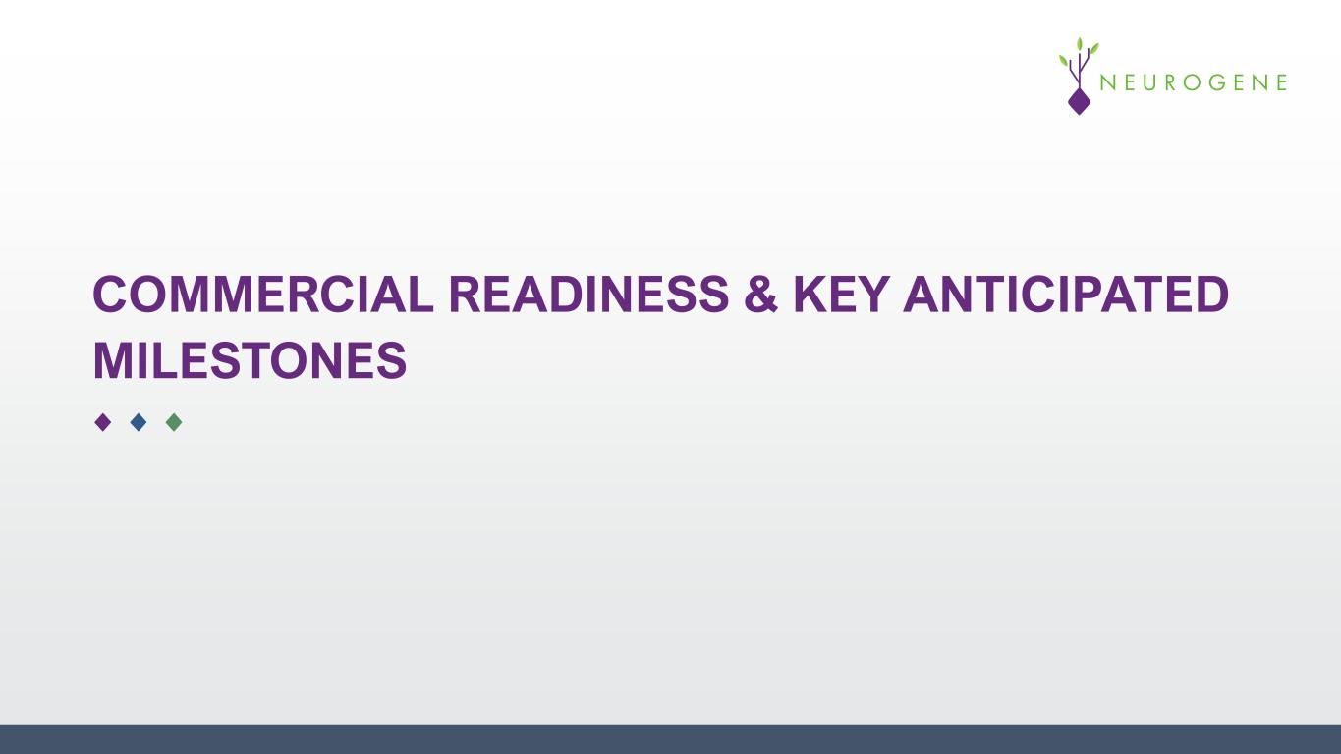
COMMERCIAL READINESS & KEY ANTICIPATED MILESTONES

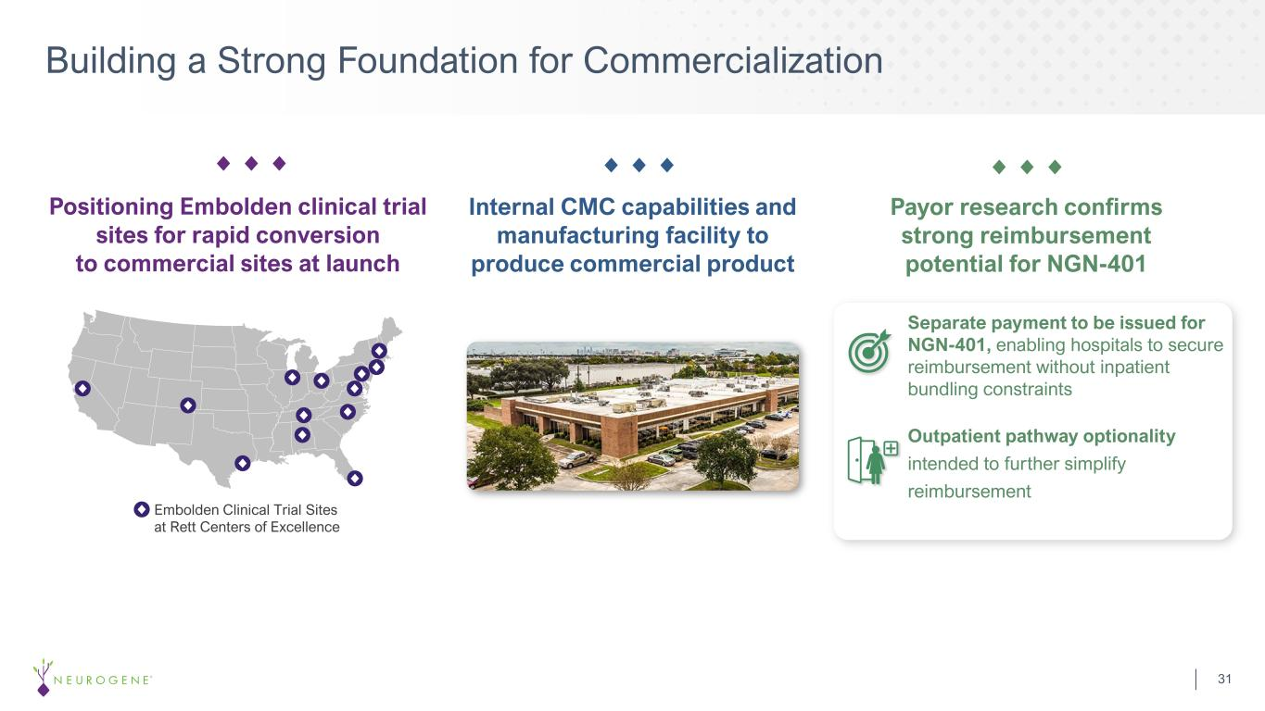
Building a Strong Foundation for Commercialization Internal CMC capabilities and manufacturing facility to produce commercial product Positioning Embolden clinical trial sites for rapid conversion to commercial sites at launch Payor research confirms strong reimbursement potential for NGN-401 Embolden Clinical Trial Sites at Rett Centers of Excellence Separate payment to be issued for NGN-401, enabling hospitals to secure reimbursement without inpatient bundling constraints Outpatient pathway optionality intended to further simplify reimbursement 31

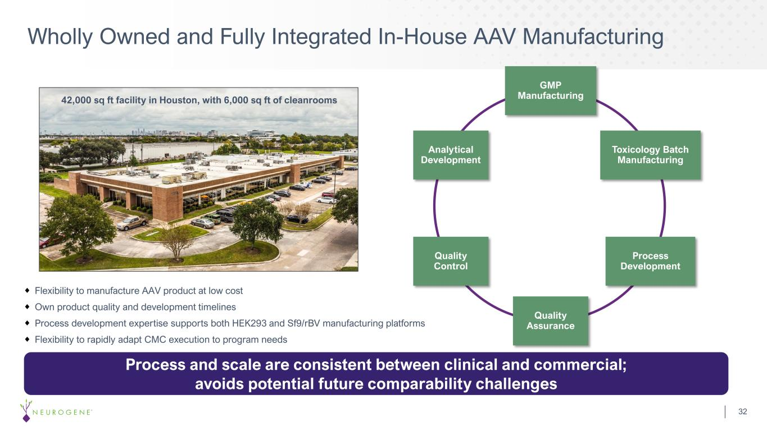
Wholly Owned and Fully Integrated In-House AAV Manufacturing GMP Manufacturing Toxicology Batch Manufacturing Process Development Quality Assurance Quality Control Analytical Development Flexibility to manufacture AAV product at low cost Own product quality and development timelines Process development expertise supports both HEK293 and Sf9/rBV manufacturing platforms Flexibility to rapidly adapt CMC execution to program needs Process and scale are consistent between clinical and commercial; avoids potential future comparability challenges 42,000 sq ft facility in Houston, with 6,000 sq ft of cleanrooms 32

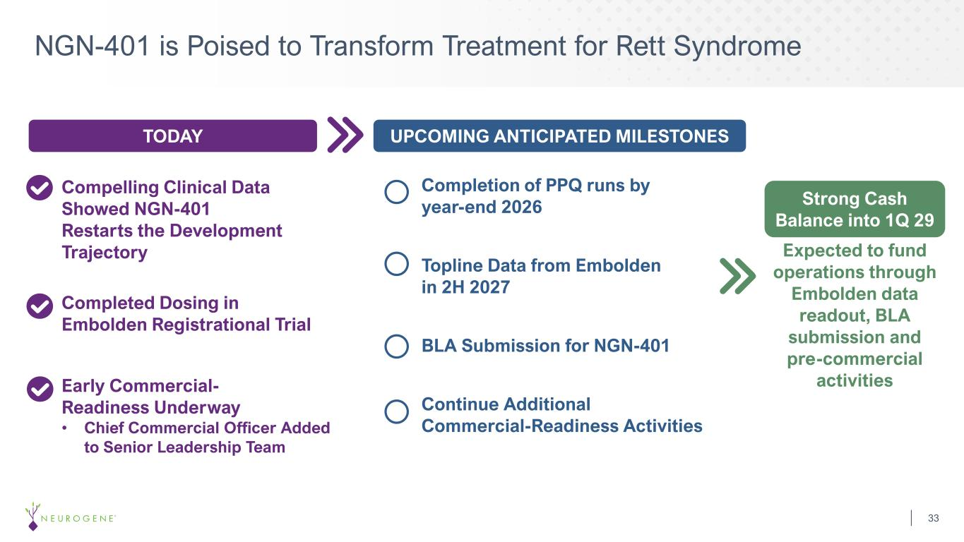
Compelling Clinical Data Showed NGN-401 Restarts the Development Trajectory NGN-401 is Poised to Transform Treatment for Rett Syndrome 33 Completed Dosing in Embolden Registrational Trial Early Commercial- Readiness Underway • Chief Commercial Officer Added to Senior Leadership Team Expected to fund operations through Embolden data readout, BLA submission and pre-commercial activities TODAY UPCOMING ANTICIPATED MILESTONES Completion of PPQ runs by year-end 2026 Topline Data from Embolden in 2H 2027 BLA Submission for NGN-401 Continue Additional Commercial-Readiness Activities Strong Cash Balance into 1Q 29

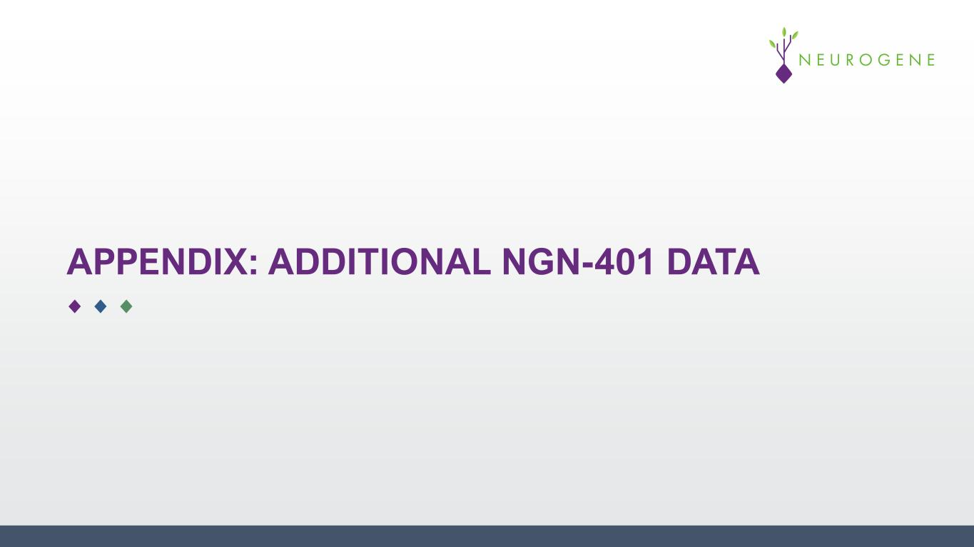
APPENDIX: ADDITIONAL NGN-401 DATA

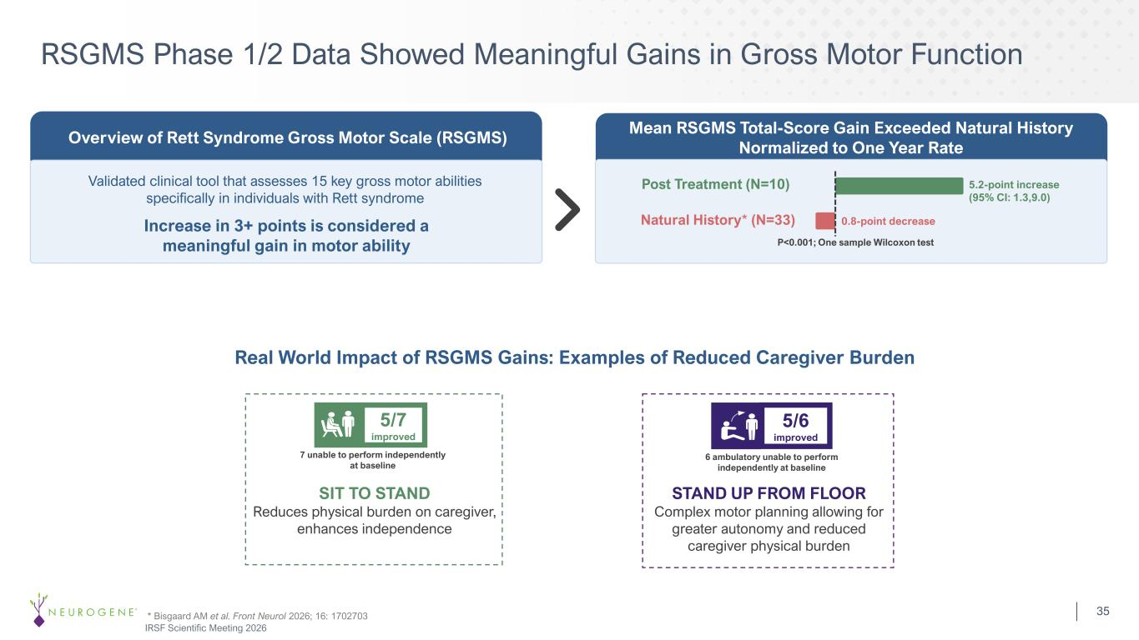
Overview of Rett Syndrome Gross Motor Scale (RSGMS) Mean RSGMS Total-Score Gain Exceeded Natural History Normalized to One Year Rate RSGMS Phase 1/2 Data Showed Meaningful Gains in Gross Motor Function Real World Impact of RSGMS Gains: Examples of Reduced Caregiver Burden SIT TO STAND Reduces physical burden on caregiver, enhances independence 7 unable to perform independently at baseline 5/7 improved STAND UP FROM FLOOR Complex motor planning allowing for greater autonomy and reduced caregiver physical burden 6 ambulatory unable to perform independently at baseline 5/6 improved Validated clinical tool that assesses 15 key gross motor abilities specifically in individuals with Rett syndrome Increase in 3+ points is considered a meaningful gain in motor ability Post Treatment (N=10) 5.2-point increase (95% CI: 1.3,9.0) Natural History* (N=33) 0.8-point decrease * Bisgaard AM et al. Front Neurol 2026; 16: 1702703 IRSF Scientific Meeting 2026 P<0.001; One sample Wilcoxon test 35

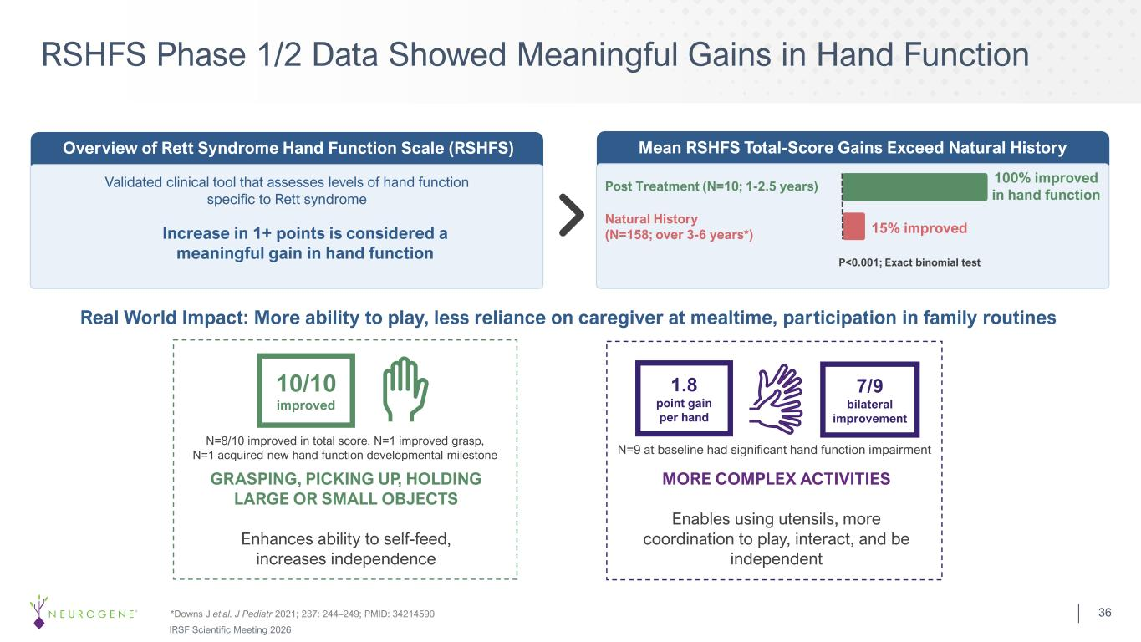
RSHFS Phase 1/2 Data Showed Meaningful Gains in Hand Function Validated clinical tool that assesses levels of hand function specific to Rett syndrome Increase in 1+ points is considered a meaningful gain in hand function Overview of Rett Syndrome Hand Function Scale (RSHFS) Mean RSHFS Total-Score Gains Exceed Natural History 36 100% improved in hand function P<0.001; Exact binomial test Post Treatment (N=10; 1-2.5 years) Natural History (N=158; over 3-6 years*) 15% improved Real World Impact: More ability to play, less reliance on caregiver at mealtime, participation in family routines GRASPING, PICKING UP, HOLDING LARGE OR SMALL OBJECTS Enhances ability to self-feed, increases independence 10/10 improved 7/9 bilateral improvement N=9 at baseline had significant hand function impairment MORE COMPLEX ACTIVITIES Enables using utensils, more coordination to play, interact, and be independent N=8/10 improved in total score, N=1 improved grasp, N=1 acquired new hand function developmental milestone *Downs J et al. J Pediatr 2021; 237: 244–249; PMID: 34214590 IRSF Scientific Meeting 2026 1.8 point gain per hand

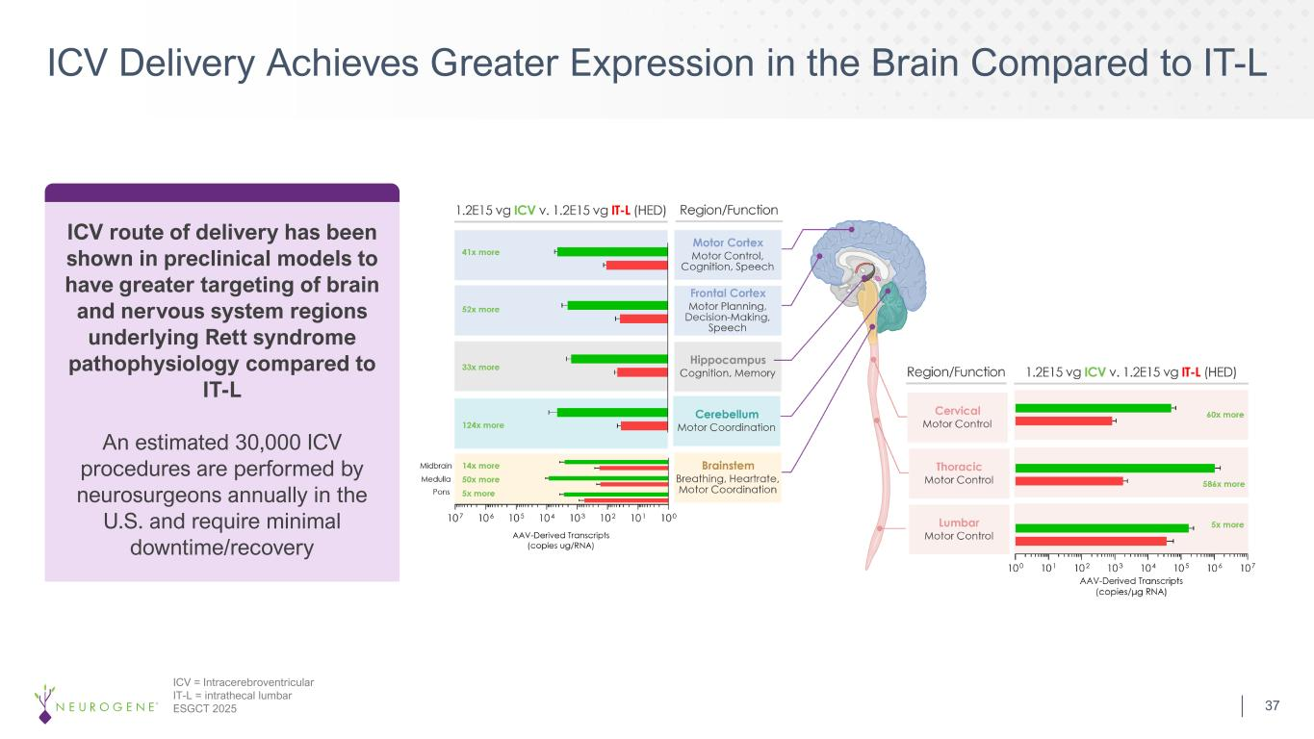
ICV Delivery Achieves Greater Expression in the Brain Compared to IT-L ICV = Intracerebroventricular IT-L = intrathecal lumbar ESGCT 2025 ICV route of delivery has been shown in preclinical models to have greater targeting of brain and nervous system regions underlying Rett syndrome pathophysiology compared to IT-L An estimated 30,000 ICV procedures are performed by neurosurgeons annually in the U.S. and require minimal downtime/recovery 37

